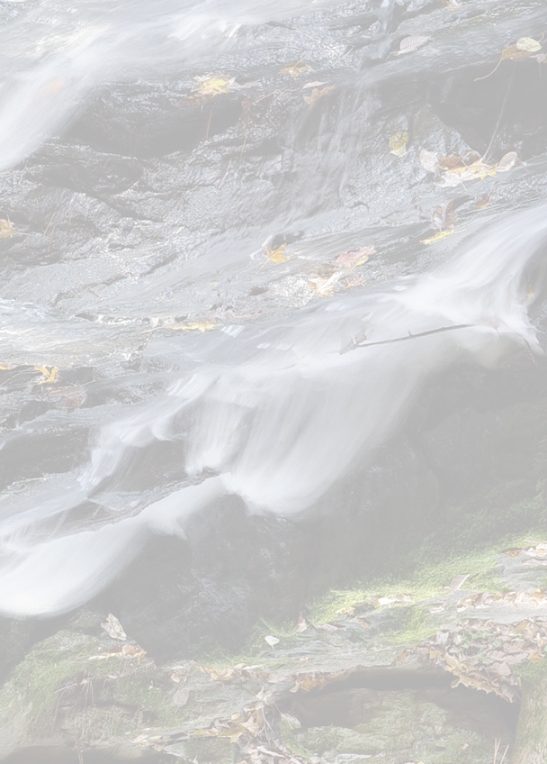

□□□□□

Appendix D:

Watershed Delineation

Appendix D:
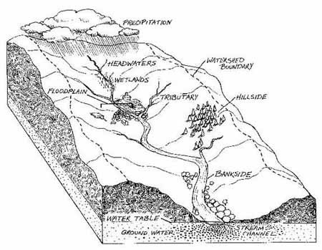
Watershed Delineation

Imagine a watershed as an enormous bowl. As water falls onto the bowl’s rim, it either ﬂows down the inside of the bowl or down the outside of the bowl.
The rim of the bowl or the water- shed boundary is sometimes referred to as the ridgeline or watershed divide. This ridge line separates one watershed from another.
Topographic maps created by the United States Geological Survey (USGS
  - minute series) can help you to determine a watershed’s boundaries.

Topographic maps have a scale of 1:24,000 (which means that one inch measured on the map represents 24,000 inches [2000’] on the ground). They also have contour lines that are usually shown in increments of ten or twenty feet. Contour lines represent lines of equal elevation, which typically is expressed in terms of feet above mean sea level. As you imagine water ﬂowing downhill, imagine it crossing the contour lines perpendicularly.
We describe basic topographic map concepts and symbols below, but more information can be found at the U. S. Geological Survey’s website on Topographic Map Symbols:
    - http://erg.usgs.gov/isb/pubs/booklets/symbols/index.html — or
    - http://erg.usgs.gov/isb/pubs/booklets/symbols/topomapsymbols.pdf

Here’s how you can delineate a watershed:
STEP 1:
Use a topographic map(s) to locate the river, lake, stream, wetland, or other waterbodies of interest. (See the example, West Branch of Big River, in Figure D-1.)
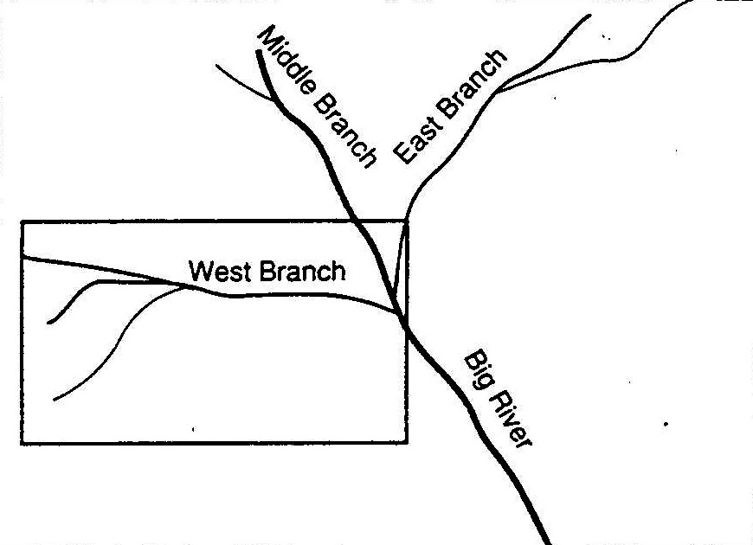
Figure D-1: West Branch of Big River

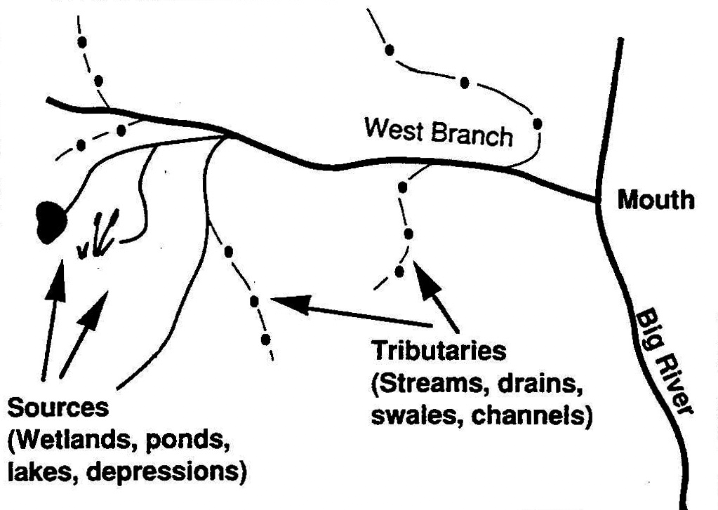STEP 2:
Trace the watercourse from its source to its mouth, including the tributaries (Figure D-2). This step determines the general beginning and ending boundaries.

Figure D-2:West Branch subwatershed

STEP 3:

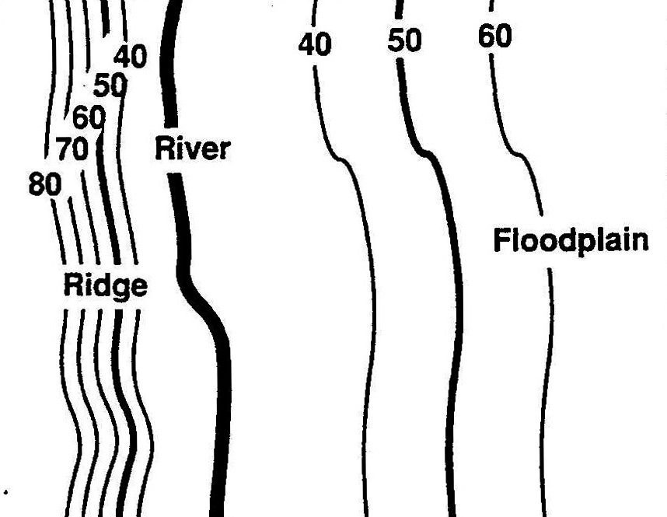Examine the brown lines on the topographic map that are near the watercourse. These are referred to as contour lines. Contour lines connect all points of equal elevation above or below a known reference elevation.
- The dark brown contour lines (thick lines) will have a number associated with them, indicating the elevation.
- The light brown contour lines (thin lines) are usually mapped at 10 (or 20) foot intervals, and the dark brown (thick) lines are usually mapped at 50 (or 100) foot intervals. Be sure to check the map’s legend for information on these intervals.
- To determine the ﬁnal elevation of your location, simply add or subtract the appropriate contour interval for every light brown (thin) line, or the appropriate interval for every dark brown (thick) line. Figure D-3 shows a point (X) at an elevation of 70 feet above mean sea level.

STEP 4:
- Contour lines spaced far apart indicate that the landscape is more level and gently sloping (i.e., they are ﬂat areas). Contour lines spaced very close together indicate dramatic changes (rise or fall) in elevation over a short distance (i.e., they are steep areas) (Figure D-4).

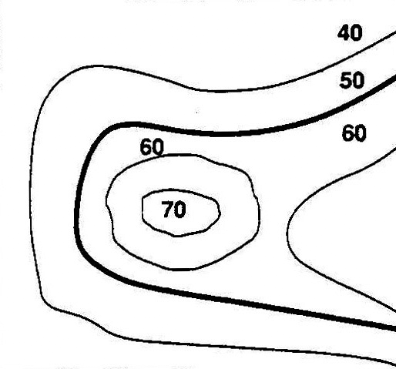

x

Figure D-3: Contour lines and an example point (X) at an elevation of 70 feet above sea level.

Figure D-4: Floodplains and ridges

STEP 5:
Check the slope of the landscape by locating two adjacent contour lines and determine their respective elevations. The slope is calculated as the change in elevation, along a straight line, divided by the distance between the endpoints of that line.
  - A depressed area (valley, ravine, swale) is represented by a series of contour lines “pointing” towards the highest elevation (Figure D-5).
  - A higher area (ridge, hill) is represented by a series of contour lines “pointing” towards the lowest elevation (Figure D-6).

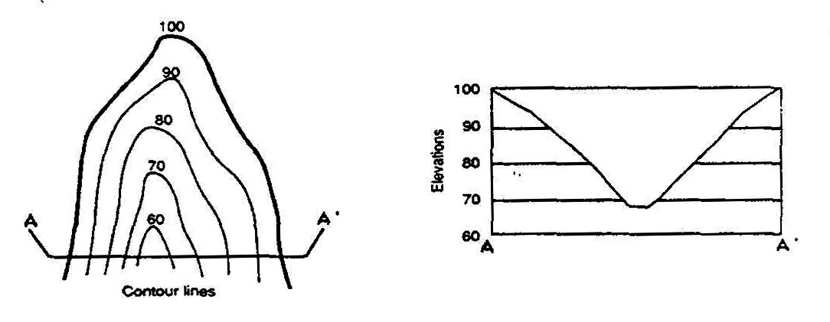Figure D-5: Valley

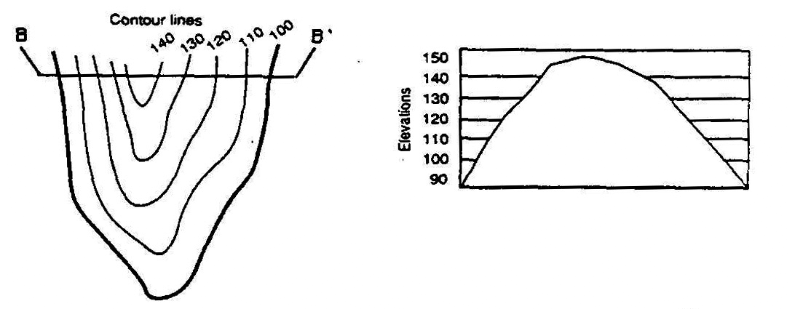Figure D-6: Ridge

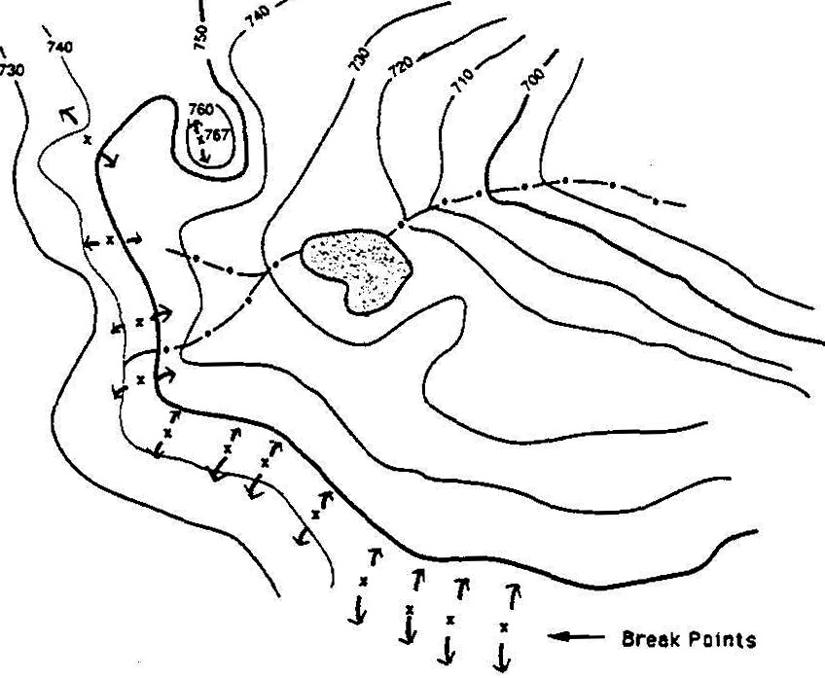STEP 6:
Determine the direction of drainage in the area of the waterbody by drawing arrows perpendicular to a series of contour lines that decrease in elevation. Stormwater runoff seeks the path of least resistance as it travels downslope. The “path” is the shortest distance between contours, hence a perpendicular route (Figure D-7).
Mark the break points surrounding the water-
body. The “break points” are the highest elevations where half of the runoff would drain towards one body of water, and the other half would drain towards another body of water (Figure D-8).
Figure D-7: Direction of drainage

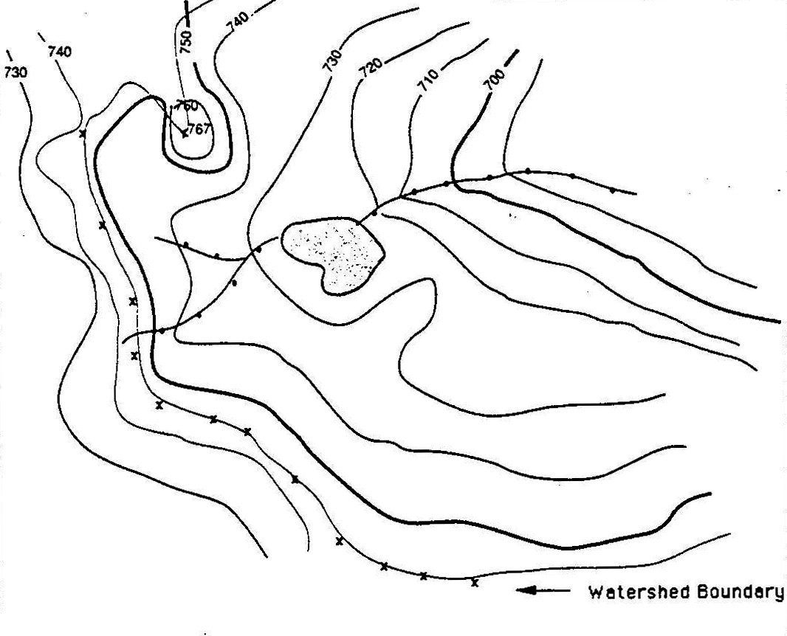STEP 8: IDENTIFY BREAK POINTS
Connect the break points with a line following the highest elevations in the area. The completed line represents the boundary of the watershed (Fig- ures D-8 and D-9).

STEP 9:
Once you’ve outlined the watershed boundaries on your map, imagine a drop of rain falling on the surface of the map. Imagine the water ﬂowing down the slopes as it crosses contour lines at right angles.
Follow its path to the nearest stream that ﬂows
to the water body you are studying. Imagine this water drop starting at different points on the watershed boundaries to verify that the boundaries are correct.

STEP 10:
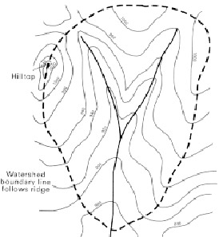Distribute copies of your watershed map to your group.

STEP 11:
Watersheds sometimes have what are termed subwatersheds within them. Rivers, large streams, lake, and wetland watershed often have more than one subwatershed (usually smaller tributary watersheds) within them.
Generally, the larger the waterbody you are examining, the more subwatersheds you will ﬁnd. Your watershed map can be further divided into smaller sections or subwatersheds if it helps organize your study better.

Figure D-8:Watershed Boundary

STEP 12:
Once the watershed and subwatershed (optional) boundaries have been delineated on the map, your team can verify them in the ﬁeld, if necessary.

Figure D-9: Idealized Watershed Boundary
(Adapted from Ammann, Allen, and Amanda Lindley Stone, Method for the Comparative Evaluation of Nontidal Wetlands in New Hampshire. 1991, from New Hampshire Department of Environmental Services.)

