Pre-Lesson Worksheet Answer Key
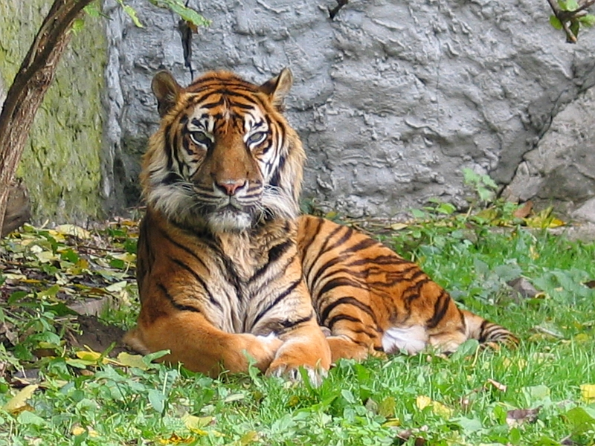
The questions below pertain to the tiger shown in this photograph.

Image source: 2004 Monika Betley, Wikimedia Commons
http://commons.wikimedia.org/wiki/File:Panthera_tigris_sumatran_subspecies.jpg

- What determines the color of the tiger’s coat?
Genes, DNA

- If the DNA sequence were to change, what would this be called?
Mutation

- Explain how a mutation could cause this tiger to have a white coat instead of an orange coat.
A mutation to the gene that codes for the coat color to be orange could cause the coat to change to white.

