**Example Student Designs**

**Example student design idea for improved above-ground storage tanks.**

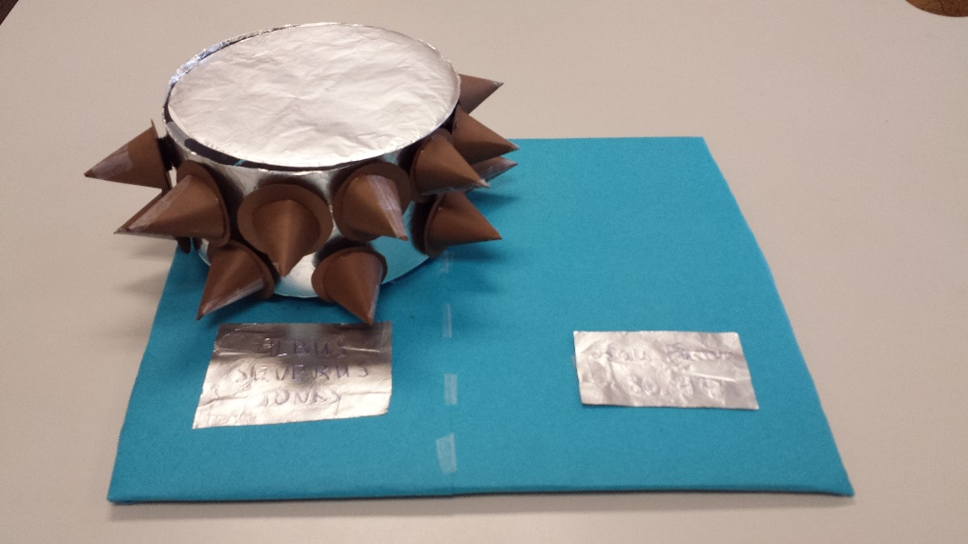

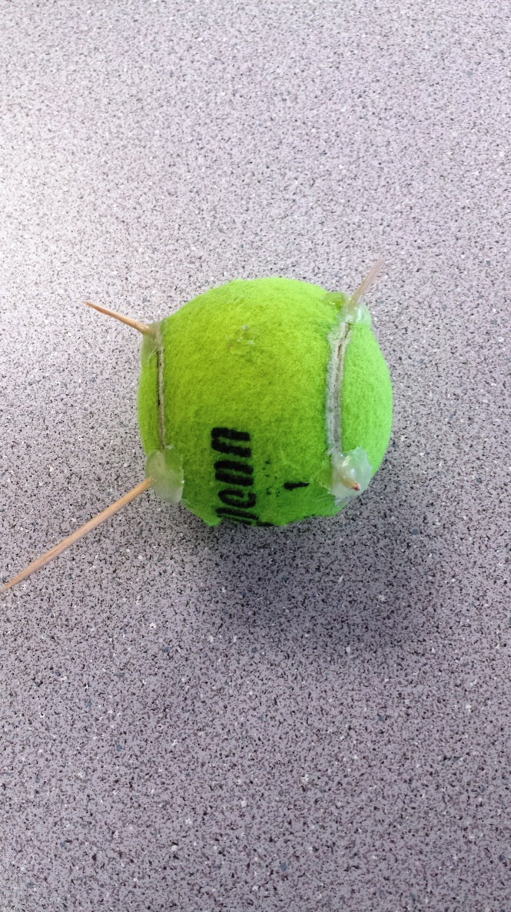

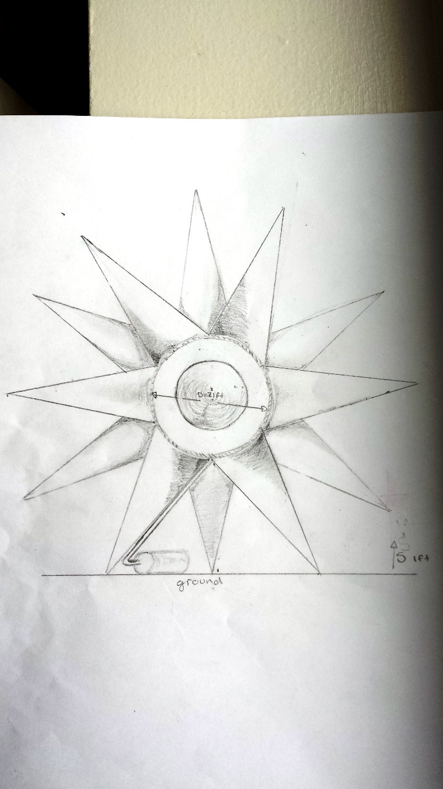

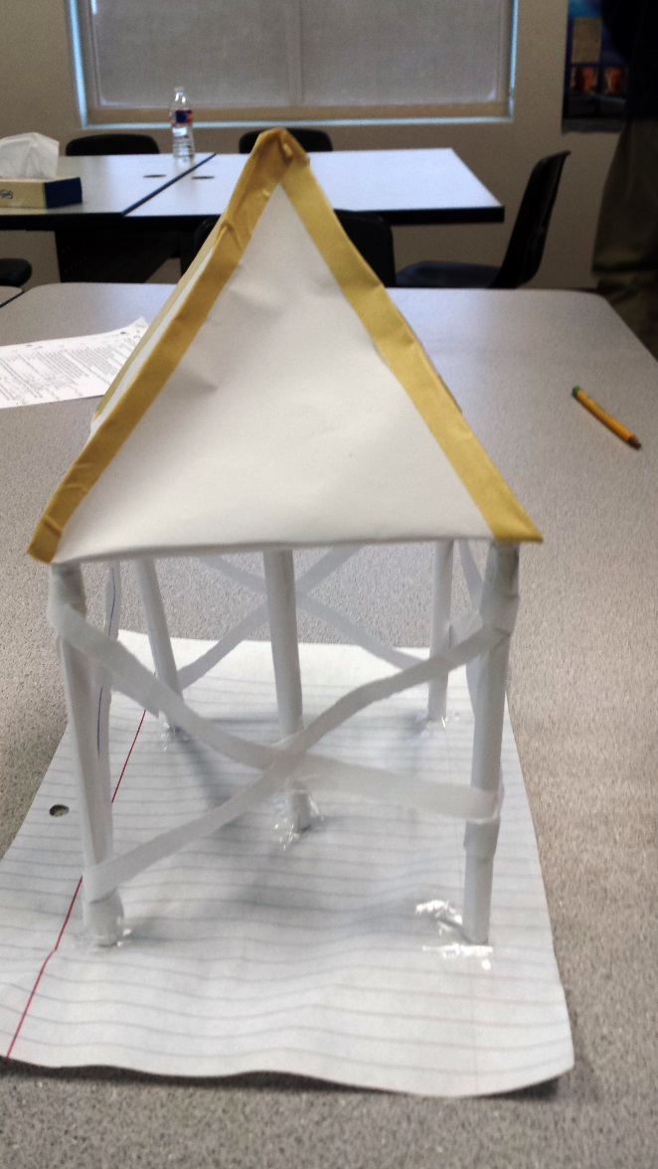

**Top left:** A model composed of toothpicks glued to a tennis ball to represent an above-ground storage tank on legs or with spikes protruding from it to protect it from debris.

**Top right:** A build-to-scale model made from cardstock covered in foil as the cylindrical part of a tank, with its curved sides covered in spikes to protect it from debris made from brown construction paper.

**Bottom left:** A drawing of a spherical tank with large protruding spikes to protect it from debris.

**Bottom right:** A model made of white copy paper and lined notebook paper. The plain paper is folded and taped to resemble a structure similar to a house on stilts with a square-based pyramid-shaped roof. The elevated square pyramid is the storage tank and the stilts protect the tank from storm surges during flooding.