Calcium Oxalate Worksheet
Inhibitor | bovine serum albumin (BSA) | Transferrin (Tf) | chondroitin sulfate A (C₄S) | citric acid (CA) | dimethyl hydroxyglutaric acid (DHG)
Protein/  Simple Molecule | Protein | Protein | Simple Structure | Simple Structure | Simple Structure
Description | Protein derived from cows | Iron-binding blood plasma glycoprotein | Usually found attached to proteins | Natural preservative | Found in urine of people with certain deficiencies
Structure | 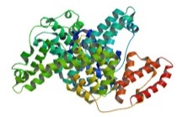 | 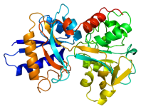 | 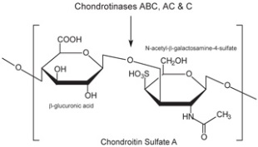 | 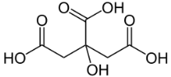 | 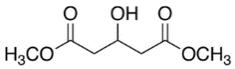
MW | 66,463 | 78,000 | 463.37 | 192.12 | 176.17
pH of solution/pKa | pH of 1% solution: 5.2-7 | pKa 6.2 | pKas in range of -3.7 to -1.9 | Three pKas in range of 3.15-5.19 | pKas in the range of -3.1 to 3.79
H-bond acceptor | N/A | N/A | 15 | 7 | 5
H-bond donor | N/A | N/A | 8 | 4 | 3
- What does a calcium oxalate crystal look like without any inhibitors? Draw.

- Draw what happens to the calcium oxalate crystal when each inhibitor is added.
bovine serum albumin (BSA) | Transferrin (Tf) | chondroitin sulfate A (C₄S) | citric acid (CA) | dimethyl hydroxyglutaric acid (DHG)

Inhibitor | bovine serum albumin (BSA) | Transferrin (Tf) | chondroitin sulfate A (C₄S) | citric acid (CA) | dimethyl hydroxyglutaric acid (DHG)
Mark on the crystal where each molecule binds
- Compare groups of inhibitors. (two groups: proteins and simple structures)
Which were the most effective at blocking growth? Speculate why one would be more effective.

- Compare inhibitors within their own group. Which ones were the most effective?
Explain why this might be.

- Do the crystals have different shapes when inhibitors are added? What might cause these different shapes? (Think about how steps grow on a crystal surface in all directions but at different rates. How does an inhibitor affect those rates?)

- Of all the inhibitors used today, which do you think would be the best choice as a possible drug? Why?

