Molecular Modeling Worksheet Answers
- Draw a molecule of ethane on your paper, and then use ChemDraw to draw it in your computer.

- Write the chemical formula for ethane.
C₂H₆
- What is the molecular weight?
30.07 g/mol
- What is the elemental analysis?
- Draw a molecule of ethanol on your paper, and then use ChemDraw to draw it in your computer.

- Write the chemical formula for ethanol.
C₂H₅O
- What is the molecular weight?
46.06 g/mol

- What is the elemental analysis?
- Describe a Newman projection and use ChemDraw to draw it in your computer.
What is the purpose of Newman projections?
Newman projections are another way to visualize chemical bonds, such as a carbon-carbon bond. Newman projections are a simplified version of drawing the ethanol molecule.
- What is the difference between staggered and eclipsed? (Please draw in ChemDraw.)
In the eclipsed conformation, the substituent atoms are within close proximity to one another, while the staggered conformation shows the substituent atoms far away from one another.
- Draw the Newman projection of ethanol in the staggered conformation.

- Draw the Newman projection of ethanol in the eclipsed conformation.

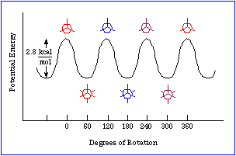
- In the energy diagram below, how does energy relate to staggered and eclipsed? Please explain.

In the diagram above, the eclipsed conformations are when the potential energy is the highest. The staggered conformations are when the potential energy is at its lowest.
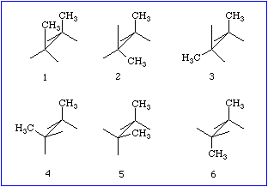
- Next to each number below, label the pictured conformations as staggered or eclipsed.

- eclipsed
- eclipsed
- eclipsed
- staggered
- staggered
- staggered

