Scaling a Figure Worksheet Answer Key
Learning Goal: How does a figure or shape change when we enlarge or reduce it?
Introduction
Below is floor plan for the interior design of a bedroom. Let’s look at what happens to the items in the design when we enlarge or reduce them.
Instructions
- Measure and record the size and length of each part of the bedroom
for the original, enlarged and reduced designs.
- Calculate the perimeter and area for each design.
- Answer the questions below.

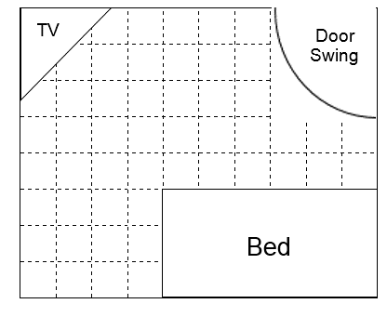
Enlarged
Original

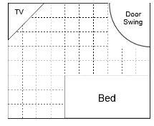
Reduced

Data Collection
- Record your measurements and calculations for the bedroom in the table below.
Bedroom | Length | Width | Perimeter | Area | Angles
Original | 4.5 cm | 3 cm | 15 cm | 13.5 cm² | 90◦
Enlarged | 13.5 cm | 9 cm | 45 cm | 121.5 cm² | 90◦
Reduced | 2.25 cm | 1.5 cm | 7.5 cm | 3.375 cm² | 90◦

- Record your measurements and calculations for the door swing (quarter circle) below.
Door Swing | Radius | Circumference | Area | Angle
Original | 1.2 cm | 1.9 cm | 1.13 cm² | 90◦
Enlarged | 3.6 cm | 5.7 cm | 10.18 cm² | 90◦
Reduced | 0.6 cm | 0.94 cm | 0.28 cm² | 90◦

- Record your measurements and calculations for the TV in the table below.
TV | Length | Width | Perimeter | Area | Angles
Original | 0.9 cm | 1.1 cm | 3.5 cm | 0.5 cm² | 45◦
Enlarged | 3 cm | 3 cm | 10 cm | 4.5 cm² | 45◦
Reduced | 0.45 cm | 0.55 cm | 1.7 cm | 0.125 cm² | 45◦

Questions
Answer the following questions based on your measurements and calculations.
- By how much was the design enlarged? How do you know? How did that change the perimeter? The area? The angles? Explain.
The design was enlarged by a scale factor of 3. We know this because the lengths increased by a multiple of 3 for each part of the bedroom. The perimeter also changed by a factor of 3. The area changed by a factor of 9. The angles did not change.

13.5 cm / 4.5 cm = 3; 10 cm / 3.5 cm = 3; 121.5 cm² / 13.5 cm² = 9; 90º/90º = 1

- By how much was the design reduced? How do you know? How did that change the perimeter? The area? The angles? Explain.
The design was reduce to half its original size. We know this because the lengths decreased by 2 for each part of the bedroom. The perimeter decreased by half. The area is one-quarter of the original size. The angles did not change.

2.25 cm / 4.5 cm = ½; 1.5 cm / 3 cm = ½; 3.375 cm² / 13.5 cm² = ¼; 90º /90º = 1

- If we were to draw a new design at quadruple (four) times the size, how would the perimeter change? How would the area change? The angles? Explain
The perimeter would be four times the size. The area would be 16 times the size (see drawing below) and the angles would remain the same.

- Which characteristics of a figure change when the original is scaled? How can you predict their new size? Which characteristics stay the same? Explain.
When a figure is enlarged or reduced, its perimeter and area change. The perimeter corresponds with the scale factor and the area changes by the square of the scale factor. The angles of the shape stay the same.

