Pre-Quiz

1) Add to the drawing to show light moving from the candle to the eye.

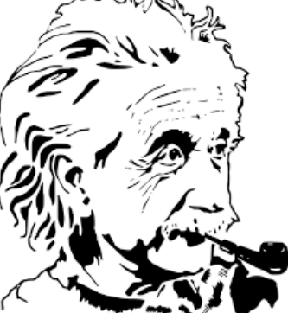

2) What, if anything, can you change in the drawing to provide a more realistic image of the light?

Answers will vary.

3) As you have learned in the past, the rate at which energy is used or produced is power. Power is measured in watts, which are joules per second. What, in a 100-watt light bulb is happening at 100 J/sec?

Answers will vary based on their knowledge base.

4) What, in a 5-milliwatt laser is happening at 0.005 J/sec?

Answers will vary based on their knowledge base.

5) Briefly compare and contrast engineering and science.

Answers will vary.

