Climate Change and Cars Worksheet Answer Key
Do gas-powered and electric cars affect our climate?

Together, we are going to find out:
- What is the greenhouse effect?
- What is the carbon cycle?
- How does transportation affect the greenhouse effect?

1. What is the Greenhouse Effect?
Instructions: After watching the video “What is the Greenhouse Effect?” answer following questions.

- Describe the greenhouse effect in your own words.

The Earth traps heat from the sun using gases in the atmosphere.

- Why is the greenhouse effect important to life on Earth?

This is how Earth maintains just the right temperature to support life.

- How do human activities impact the greenhouse effect?

Extra carbon dioxide is being released into the atmosphere which makes the Earth trap more and more heat which leads to a warmer planet.

- What else did you learn from the video?

Answers will vary.

2. Carbon Dioxide (CO₂) on Earth
Carbon dioxide, also called CO₂, is a type of gas naturally found on Earth. Take a few minutes to look over the Carbon Cycle image below. What do you notice?

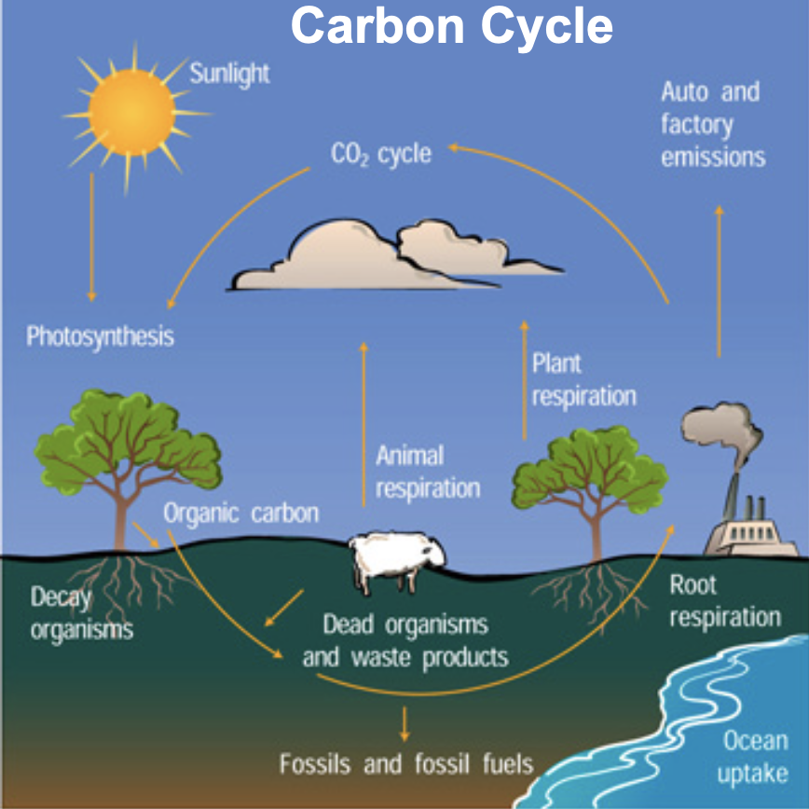

After watching “What is the Carbon Cycle?” video, answer the following questions.
- Where is CO₂ released into the atmosphere?
From the video transcript: “Marine organisms from marsh plants to fish, from seaweed to birds, also produce carbon through living and dying. Sometimes dead organisms become fossil fuels that go through combustion, giving off CO2, and the cycle continues.”

- How does CO₂ move from the atmosphere through Earth?

From the video transcript: “Most carbon is stored in rocks and sediments, while the rest is stored in the ocean, atmosphere, and living organisms”

Let’s review!
- CO₂ comes from natural sources…(respiration of animals and humans, decay of dead plants & animals, etc.)
- CO₂ also comes from human sources…(burning of fossil fuels for energy in cars, power plants, etc.)
- CO₂ moves through Earth’s atmosphere (air), hydrosphere (water), biosphere (living things), and geosphere (land).

3. How are humans increasing CO₂ levels in the atmosphere?
Look over the graph below showing the amount of CO₂ in the atmosphere.

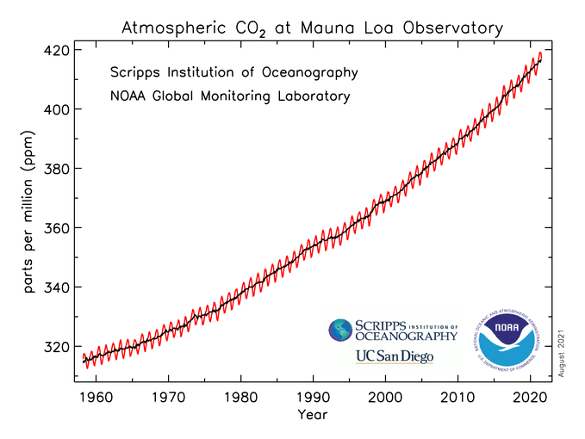

- What patterns do you notice in the graph?

CO₂ increased by 100 ppm in the last 60 years.

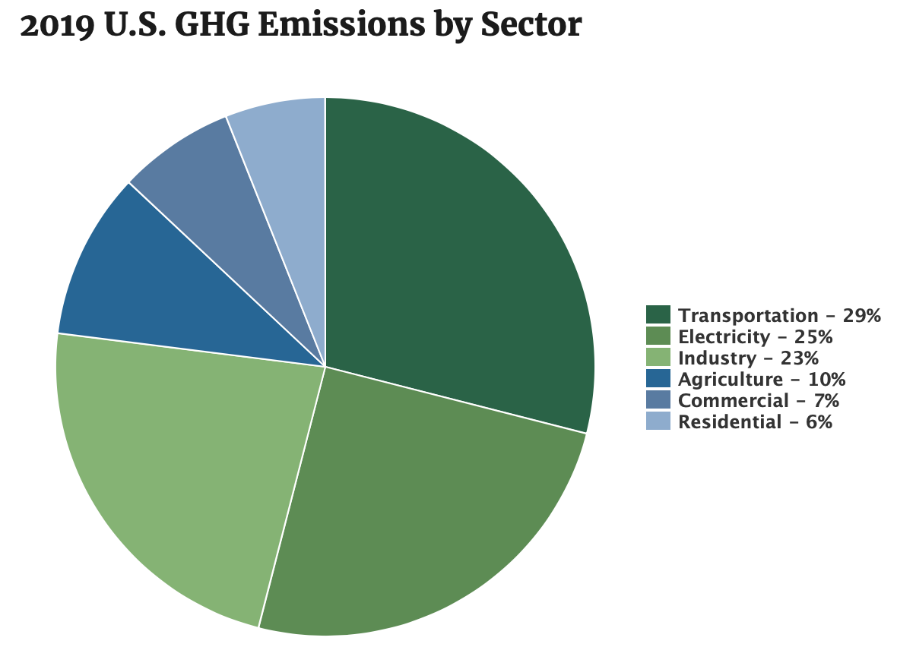
- Look at the image above. What category of human activities contributes the most to the extra CO₂ in the atmosphere?

Transportation

4. Carbon emissions (exhaust) from cars.
After watching the video “What if Carbon Left Your Tailpipe as Solid Chunks?” think-pair-share the following questions as a class:

- What do they show coming out of the car’s tailpipe in the video? What is it?

One gallon of burned fuel in solid form. (As opposed to gas.)

- How many car “turds” does an average car dump per year? Per mile? How is that shown in the video?

Over one ton of carbon per year. 5 lbs each mile. Piles of charcoal (carbon).

Class Reflection: Share your thoughts on the following questions as a class:
- How do you get to school? Do you take the bus? Do your parents drop you in their car? Do you walk? Do you carpool with a friend?
- Which form of transportation do you think is cleaner?
- Which form of transportation do you think is less clean?
- Are there cars out there that do not have exhaust or (or “turds” like the car in the video)?

