Famous Failures Case Studies
Tipping of the Titanic
On April 14, 1912, the Titanic—the largest and most elegant ship of the time—-struck an iceberg and sank into the waters of the Atlantic Ocean, resulting in the deaths of more than 1,500 people. What caused this incredible ship to sink? The Titanic had a double-bottomed hull divided into 16 different watertight compartments. When the engineers initially tested the ship, they determined that at least four of these components could be flooded without sinking the ship. However, in the design, these compartments were not sealed at the top, and water was able to flow from compartment to compartment (like water filling an ice cube tray). When the starboard side of the Titanic scraped the iceberg, small ruptures caused several compartments to fill, tipping the ship to one side and ultimately causing it to sink.
The Titanic during sea trials.
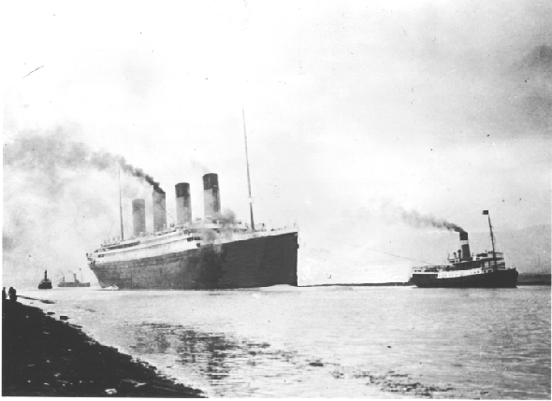
Toppling of the Tacoma Narrows Bridge
The original Tacoma Narrows Bridge was the first suspension bridge built across the Puget Sound in Washington. The bridge was strong but relatively light, narrow, and as it turns out—(too) flexible. On the morning of November 7, 1940, in a 42 mph (68 kph) wind, the 2,800-foot (853-m) main bridge span went into a series of torsional oscillations (side-to-side and up-and-down motion) in which the amplitude (size of the motion) steadily increased. This movement tore several suspension cables and broke the main span, causing the bridge to collapse. The failure of the bridge was a shock to the engineering community. How could a structure weighing more than tens of thousands of tons topple in moderate wind? Most experts agree that the collapse had something to do with a phenomenon called “resonance”—the same force that causes a soprano’s voice to shatter glass. Although the engineers had designed the bridge to withstand the pressure of winds much greater than 42 mph, they did not consider the interaction of moderately strong wind and the flexibility of the bridge.
The new Tacoma Narrows Bridge.
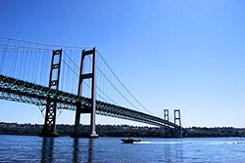
____________________________________________________________________________
QUESTION: What factor(s) did the engineers of both the Titanic and the
Tacoma Narrows Bridge fail to include in their engineering analysis?

