The Theory of Plate Tectonics Worksheet
Objective: Gather evidence to explain the theory of plate tectonics.
Materials: Work in pairs sharing one computer with Internet access.
Engage:
- What continent do you live on? Can you think of any ways the continent has changed over time?
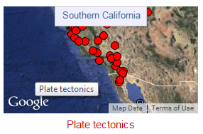
Explore: Navigate to the Earthquakes Living Lab at http://www.teachengineering.org/livinglabs/earthquakes/.
Notice the four main components of the Earthquakes Living Lab.
- Select the second option, the “Southern California” box. > click the third link on the right side of the page titled, “How have the Earth’s continents changed over time?” at http://www.ucmp.berkeley.edu/geology/anim1.html.
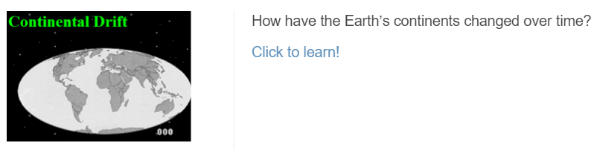

- Compare the map of the world today (such as the real-time earthquake map) to a map of the world 250 million years ago (called Pangaea). Use the interactive continental drift map to watch the change in the Earth’s landforms over millions of years.
- As you watch the animation, record at least three examples of how the continents have changed their positions over time.

- If the plates continue to move in this pattern, draw a sketch of what the world might look like 250 million years in the future.

- Explain: Navigate back to the Earthquakes Living Lab main page and click on the second and fourth links titled, “What is the Theory of Plate Tectonics? What evidence supports the Theory of Plate Tectonics?” and “General information on plate tectonics, including images, animations and explanations.” Explore more about the theory. Read the background information and answer the following questions:

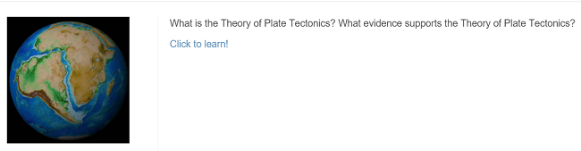

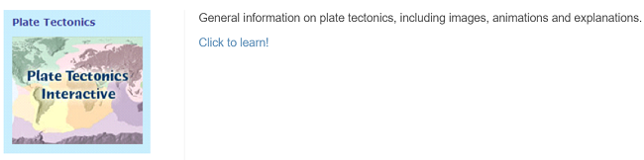

- What might have caused the continents to move? (Hint: What is the name of this theory?)

- Describe some important information related to this theory.

- Elaborate: Find and record evidence used to explain how continents have moved over time. Explore the following links to identify explanations and examples of evidence. You may also use any of the other links located on the Earthquakes Living Lab page. Use a graphic organizer (such as the chart below) to record your ideas.
- Seafloor spreading and earthquakes: http://pubs.usgs.gov/gip/dynamic/developing.html
- Fossils: https://education.seattlepi.com/list-describe-evidence-plate-tectonics-theory-5600.html
- Volcanoes: http://www.divediscover.whoi.edu/hottopics/seamounts.html
Category | Evidence Examples and Explanations
sea floor spreading
fossils
earthquakes
volcanoes
- Looking at the information you compiled in your chart above, explain one way the theory of plate tectonics can relate to engineering.

- Evaluate: In the early 1900s Alfred Wegener proposed the continents were “drifting.” The scientific community did not support his theory due to a lack of scientific evidence. Using what you learned in this activity, would you support Wegener’s hypothesis or not? Write a two-paragraph essay that explains your position.

