Pete’s Burger Palace Activity Packet
Ponder This Problem at Pete’s!
Pete’s Burger Palace is a local, independently owned fast food restaurant near the local high school in Pleasantville, USA. Five years ago, a Mr. Quickies opened several blocks away from Pete’s. Pete’s burgers feature higher-quality ingredients and most locals agree that Pete’s food is superior, but since Mr. Quickies opened, Pete’s has seen a steady decrease in sales each year. The owner of Pete’s speculates that this is because Mr. Quickies offers faster service and lower prices. Pete’s has a real problem keeping up with orders, especially at lunch and dinner time. Students from the nearby high school usually go to Mr. Quickies for lunch, because if they eat at Pete’s they will be late getting back to class. Customers sometimes wait 20 minutes to receive their orders during busy times—not exactly “fast food!” Review the following policies along with the floor plan and try to identify ways that Pete’s could be more efficient.
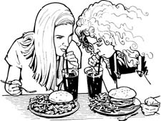
The big question: How could Pete earn the greatest profit while spending the least amount of time, energy, materials and costs?

Pete’s Burger Palace Menu
The Excali-Burger
One-quarter pound Angus beef burger on a toasted bun, served with tomatoes,
pickles, cheddar cheese, iceberg lettuce, ketchup and mustard $4.95
Merlin’s Monstrous Chicken Sandwich
Crispy chicken patty on a toasted bun, served with tomatoes, pickles,
pepper-jack cheese, iceberg lettuce, and Pete’s Secret Sauce $4.95
Nuggets of the Round Table
10-piece serving of crispy chicken nuggets, deep fried to perfection $3.95
Faerie Fries
A Pete’s Burger Palace specialty, freshly prepared French fries hand-cut
from real Idaho potatoes $1.50
Gallahad’s Gulps
Fountain drinks, 16 oz. size only: Cola, Diet Cola, Lemon-Lime, Root Beer, Dr. Sizzle $1.50
(kiddie size free for children under 10)

Employee Responsibilities at Pete’s
The chart below includes descriptions of the five employee stations at Pete’s. As you read it, keep in mind the following information:
- A maximum of five employees may be working at one time at Pete’s—the kitchen is too small to accommodate more than five people. Right now, the only times when five employees work at once are during the lunch and dinner rushes.
- While cashiers may not handle food during business hours, they may do so before the restaurant opens or after it closes—provided that they wash their hands thoroughly after handling money.
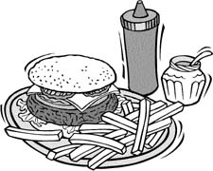
- Roles are flexible at Pete’s. While some employees might be better cooks than cashiers or vice versa, all employees are trained to work all five stations.
- Primary responsibilities: These tasks must be completed immediately, before any other responsibilities.
- Secondary responsibilities: If an employee is not immediately engaged in completing a primary responsibility, s/he should work on his/her secondary responsibilities. These tasks are just as important as primary responsibilities and must be completed, but need not be done immediately.
Role | Responsibilities
Cashier #1 (drive-thru) | Primary Responsibilities  - The drive-thru cash register must be open at all times.  - There is always one cashier in charge of taking orders and handling money at the drive-thru window.  - If no other cashiers are clocked in, cashier #1 must also take orders from customers who walk into the restaurant.  Secondary Responsibilities  - While not taking orders, stocks cups, napkins and condiments.
Cashier #2 | Primary Responsibilities  - This cashier records orders and handles money at the counter.  Secondary Responsibilities  - While not taking orders, stocks cups, napkins and condiments.  - Refills the soda fountain.
Cashier #3 | Primary Responsibilities  - This cashier records orders and handles money at the counter.  Secondary Responsibilities  - While not taking orders, stocks cups, napkins and condiments.  - Also refills the soda fountain.  NOTE: Only three cashiers work at the same time during the lunch and dinner rush, so the third cashier usually does not have much time to do extra tasks.
Grill | Primary Responsibilities  - The employee on the grill is in charge of cooking all of the meat (hamburger and chicken) as well as retrieving it from the walk-in refrigerator.  - She is also in charge of retrieving drink and ice cream orders.  Secondary Responsibilities  - She and the assembler take turns frying French fries and cutting potatoes.
Assembler | Primary Responsibilities  - The assembler is in charge of putting cooked orders together: portioning orders of fries, building burgers (bun, meat, veggies, condiments) and assembling baskets.  - He is also in charge of retrieving drink and ice cream orders.  Secondary Responsibilities  - If any breaks occur between orders, the assembler stays ahead of the game by slicing/shredding vegetables and potatoes.
An Average Day at Pete’s
Time | Action
10:30 AM | - One employee arrives at the restaurant and begins to prepare for opening by completing any stocking/cleaning that was not done the night before, and opening cash registers.  - Turns on the deep fryer and milkshake/ice cream machines; both machines take 20 minutes to warm up.  - If any time is left before opening, prepares food (slicing tomatoes, shredding lettuce, cutting potatoes for French fries, toasting hamburger buns). Employees use a manual hand-slicer to slice all of the potatoes for French fries.
11AM | - Pete’s opens for business.  - A second employee arrives to help out. One employee runs a cash register, the other handles food prep.  - These two employees work on preparing for the lunch rush (continuing to prepare food as listed above), but must stop what they are doing whenever a customer places an order.
Noon-2PM  LUNCH RUSH | - A total of five employees work the lunch rush.  - Every station is occupied.  - Employees rush to keep up with the orders, but service often slows down considerably during this time.
2PM | - Three employees do their best to prepare for the dinner rush by prepping food, cleaning and stocking. These tasks are interrupted whenever a customer places an order.
5-7PM  DINNER RUSH! | - Five employees share the dinner rush in the same way they shared the lunch rush.
7:30-10PM | - Three employees remain in the store until closing. Although the restaurant is not busy, orders are steady so there is not much time to prep.
10:00-10:30PM | - Two employees close up the restaurant. They are responsible for cleaning both the kitchen and the dining areas, and closing out the cash registers.  - They also must restock cups, napkins condiments, etc.  - As a strict policy, employees must clock-out by 10:30, so if employees do not finish their tasks, the morning employees must pick up the slack.

Employee Testimonials
Many of Pete’s employees have a thing or two to say about how things could be improved at the restaurant! Here are a few of their suggestions:
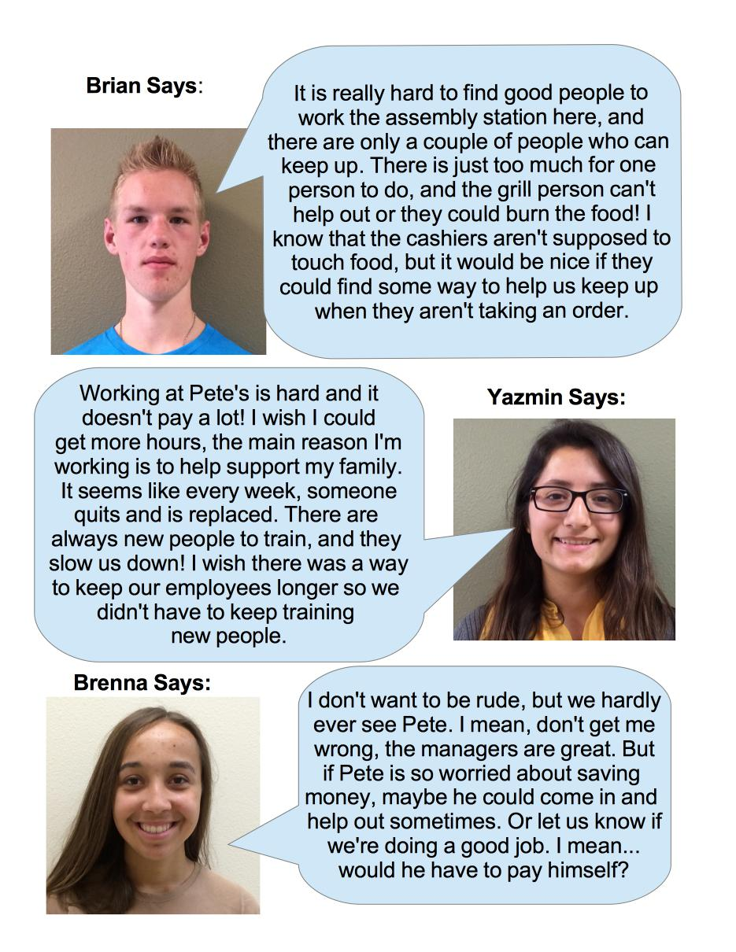

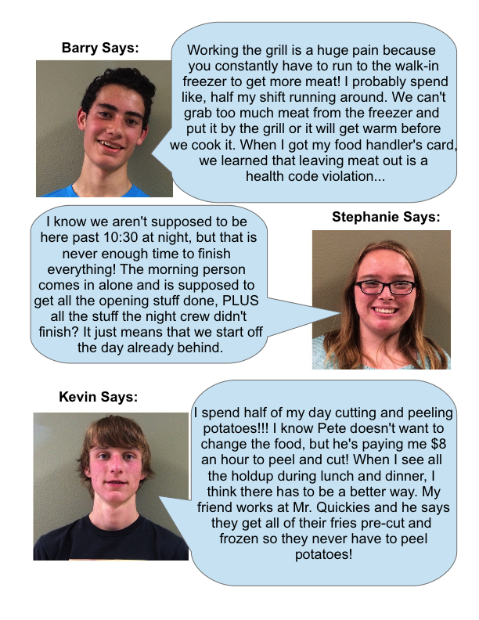

Pete’s Parameters
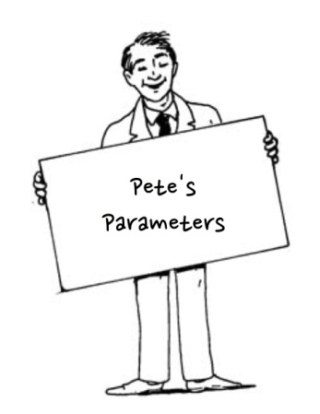

Now that you’ve heard what the employees have to say, it is time to consider Pete’s side of the story!
Be sure to keep these guidelines (aka “constraints”) in mind when you’re coming up with your solution!
- One of the reasons people keep coming back to Pete’s is because of our excellent food! I’m not going to cut corners on ingredients or quality. This is one of the last restaurants where you can get real, hand-cut fries!
- No one can stay past 10:30 PM—if I didn’t have a firm clock-out time, these kids would take all night! I can’t be hosting slumber parties on my dime! Plus it’s bad for high school kids to be out so late; they have school in the morning.
- Labor hours are a huge expense! We have to be strict about how many hours are being worked per day. Now I understand that we’re trying to find a new system, so I’ll experiment with adding more hours to the schedule. But under NO CIRCUMSTANCES will I pay for more than 30 hours in a day! And no employee can work more than 8 hours in a day—otherwise I’ve got to pay overtime and healthcare! And one more thing—if I’m paying for 30 hours in a day, I’d better see results!
- I don’t have the money to buy a bunch of newfangled kitchen gadgets—what’s wrong with what we have here? But if you have one or two small suggestions for equipment that could save time, I’d consider it.
- I’m not saying I’m going to knock out any walls, but our kitchen has been the same for 20 years—maybe it’s time to rearrange! Take a look at the kitchen floor plan and let me know how you’d move things around.
- Don’t forget, employees cannot handle food and money at the same time! That’s just unsanitary!

Task 1. Employee Responsibilities
Review the “Employee Responsibilities” chart above and decide what you would change and keep the same about each station. Which responsibilities would you delegate to each station? How could the stations help each other out? Would you eliminate any of these stations entirely in order to create new ones? You are welcome to use the same station titles or create new ones!
Hint: Which stations currently have the most responsibilities? How could you efficiently take some of their responsibilities off of their hands without violating Pete’s Parameters?
Station | Responsibilities

Task 2. An Average Day at Pete’s
Review “An Average Day at Pete’s” above and decide what you would change and keep the same about an average day: What tasks should be done at which times? When are more employees needed to pick up the slack?
Using the names of the employees you met in the testimonials section, write up a schedule for a new average day at Pete’s. Include the names of the employees, when they are clocking in/out, which stations they are each working, and tasks that should be accomplished at specific times. Use the following Mr. Quickies schedule example (on the next page) for inspiration!
Hints:
- How could Pete open for business without needing to complete unfinished tasks from the night before?
- In this schedule example, time is represented in “blocks” (when employees are assigned to the same station for long periods of time) to save space. In your schedule, feel free to indicate time by the hour or in your own blocks!
Mr. Quickies Schedule Example
Time | Employee names and stations
 | Tasks | Brenna—Assembler | Kevin—Grill | Stephanie—Cashier | Barry—Drive Thru Cashier | Yazmin—Cashier | Brian—Cashier | Clara—Assembler | Kyung—Grill | Donna—Cashier
noon-2PM | Take counter orders |  |  | X |  | X
 | Take money |  |  | X | X | X
 | Take drive-thru orders |  |  |  | X
 | Prep food | X | X
 | Work grill |  | X
 | Work assembly | X | X
 | Pour drinks | X | X
 | Run ice cream/shake machine | X | X
2PM-5PM | Take counter orders |  |  |  |  |  | X |  |  | X
 | Take money |  |  |  |  |  | X |  |  | X
 | Take drive-thru orders |  |  |  |  |  | X |  |  | X
 | Prep food |  |  |  |  |  |  | X | X
 | Work grill |  |  |  |  |  |  |  | X
 | Work assembly |  |  |  |  |  |  | X
 | Pour drinks |  |  |  |  |  |  | X | X
 | Run ice cream/shake machine |  |  |  |  |  |  | X | X
Task 3: Labor Hours
Fill in the following chart to track who worked today and for how long. Then calculate the total number of hours that were worked today. Is the total more or less than Pete’s Parameters specifies?
Employee Name | Shift worked (times clocked in/out) | Total hours worked
Total labor hours

Task 4: Floor Plan
Review the floor plan of Pete’s kitchen and decide how you might rearrange it. Consider how far employees must walk in order to reach the appliances and food items they need. What could be moved to make their trips shorter?

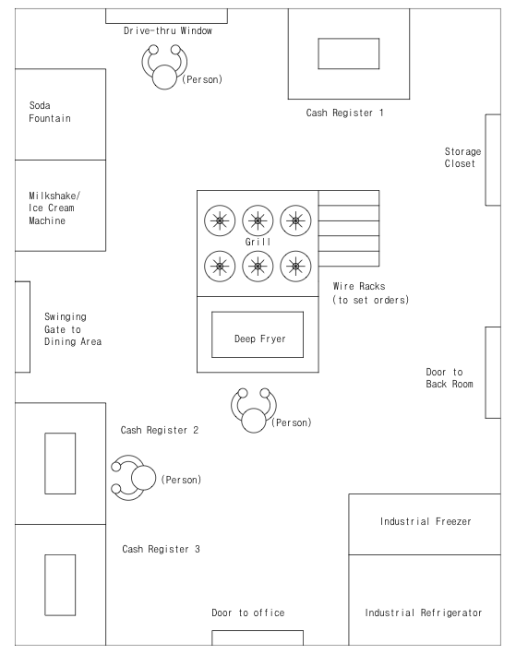

Pete’s Existing Kitchen Floor Plan

Sketch your updated floor plan below.

Task 5: Final Recommendations
Take this opportunity to convince Pete why all your proposed changes are necessary, as well as any further suggestions you have. Be sure to defend your changes to the schedule, employee responsibilities and floor plan. Explain any further suggestions you have for Pete, such as appliances to purchase. Keep in mind that you are trying to politely convince Pete that your suggestions are superior to what he is doing now. Write Task 5 as an argumentative essay in a five-paragraph essay format.

