Appendix A: Student Activity Handout

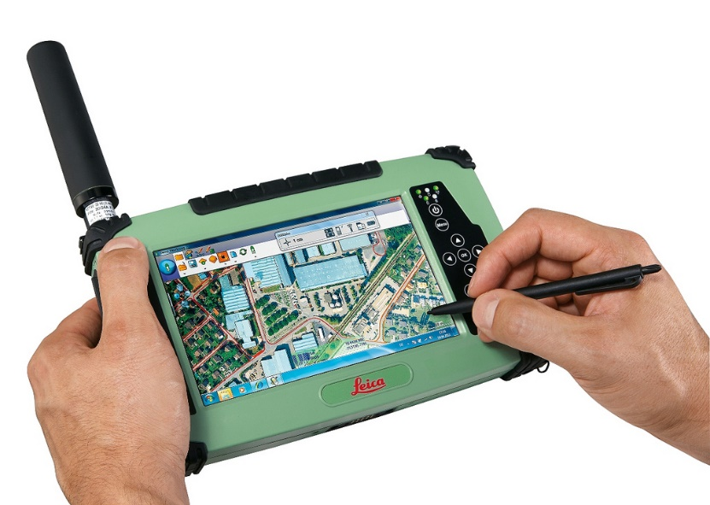
Introduction
Now that you have been introduced to GPS and GIS technology, it’s your turn to get hands-on with them out in the field. You will be put into groups and tasked with finding various targets, called geocaches, using a GPS enabled device. The method between which your GPS and computer will depend on several factors, including your class size, the number of devices available for use in your classroom, your group size, and type of GPS program with which your device is equipped. You will be using the program Google Earth as your GIS technology.

Remember that as you work, you are a civil engineer who is trying to make this area more accessible to the public. You will be constructing a pathway and a fence in the area. A real engineer would need to walk the area with a GPS too!

The Activity
Your group will be given a latitude and longitude, also known as GPS coordinates, showing the location of a geocache. The geocache will contain hints (in the form of geometry problems) as to the location of another one of the geocaches in your field. When you find a new geocache, you must save the GPS coordinates on your GPS device as a waypoint. A waypoint is simply a marker on a GPS map which records data such as the GPS coordinates, elevation, and time of day. Some software may also name the location automatically, but your teacher may want you to rename waypoints.

You need to be able to access the compass readings from your GPS. See the following chart to help you here.
0° or 360° | North
90° | East
180° | South
270° | West

Part 1: Navigating the Geocaches
Objective(s):
- Use GPS technology to locate points given a latitude and longitude to determine locations on Earth and store those points digitally by transferring latitude and longitude data from a GPS-enabled device to GIS software (Google Earth).
- Solve problems related to angle measurements and angle relationships, such as complementary and supplementary angles, and triangle and quadrilateral angle relations.
Instructions
We will go over the activity as a class to make sure you understand everything that is being asked of you, and there are written instructions here.
Below, you will keep track of the information you obtain at each geocache. This includes the GPS location (latitude and longitude) and answers to questions solved at each geocache.

What students need to do at each geocache:

- Create a new waypoint on your GPS and name it according to your teacher’s direction. You must create a waypoint to send to Google Earth at each geocache location.
- Log your location on the handout using latitude and longitude.
- Answer two geometry questions to determine how far and in what direction you need to travel to find your next geocache.

Each geocache has two geometry questions located inside. One will have an answer that is an angle measurement. This is the angle on your compass (the bearing) that you will travel to find your next geocache. The other answer will result in a distance, in meters. This is the distance you will travel to find the next geocache.

Geocache 1 (latitude and longitude provided by the teacher)
Waypoint Name:

Latitude: (remember to include the degree symbol and north or south)

Longitude: (remember to include the degree symbol and east or west)

Show your work for geocache #1 questions below.

Problem 1 (this will tell you the compass heading in degrees to travel to the next waypoint):

Problem 2 (this will tell you the meters to travel to the next waypoint):

My group needs to move _________meters at a compass heading of ________________degrees.

Geocache 2
Waypoint Name:

Latitude: (remember to include the degree symbol and north or south)

Longitude: (remember to include the degree symbol and east or west)

Show your work for geocache #2 questions below.

Problem 1 (this will tell you the compass heading in degrees to travel to the next waypoint):

Problem 2 (this will tell you the meters to travel to the next waypoint):

My group needs to move _________meters at a compass heading of ________________ degrees.

Geocache 3
Waypoint Name:

Latitude: (remember to include the degree symbol and north or south)

Longitude: (remember to include the degree symbol and east or west)

Show your work for geocache #3 questions below.

Problem 1 (this will tell you the compass heading in degrees to travel to the next waypoint):

Problem 2 (this will tell you the meters to travel to the next waypoint):

My group needs to move _________meters at a compass heading of ________________degrees.

Geocache 4
Waypoint Name:

Latitude: (remember to include the degree symbol and north or south)

Longitude: (remember to include the degree symbol and east or west)

Show your work for geocache #4 questions below.

Problem 1 (this will tell you the compass heading in degrees to travel to the next waypoint):

Problem 2 (this will tell you the meters to travel to the next waypoint):

My group needs to move _________meters at a compass heading of ________________degrees.

Geocache 5
Waypoint Name:

Latitude: (remember to include the degree symbol and north or south)

Longitude: (remember to include the degree symbol and east or west)

Show your work for geocache #5 questions below.

Problem 1 (this will tell you the compass heading in degrees to travel to the next waypoint):

Problem 2 (this will tell you the meters to travel to the next waypoint):

My group needs to move _________meters at a compass heading of ________________degrees.

Part 2: Scaling Down
Objectives:
- Use GPS technology to locate points given a latitude and longitude to determine locations on Earth and store those points digitally by transferring latitude and longitude data from a GPS to GIS (Google Earth).
- Solve problems involving scale drawings of geometric figures, including computing actual lengths and areas from a scale drawing and using appropriate tools such as a protractor.
- Relate GPS and GIS to engineering.

For Step 2, you will be more active in your role as a civil engineer. Your boss wants to know the area on the surface of the earth that is contained by the geocaches. He also wants to see a scaled sketch of the area, and you need to make some calculations to figure out how much materials you will need for a few projects associated with the area.

Now that you have found all of the geocaches, you will use Google Earth to map your waypoints. Then, you will calculate the area of the shape you created and draw a scale representation of the shape on graph paper.

- Upload your data to Google Earth

Your teacher will give you instruction on how to upload your GPS data to Google Earth depending on the software you are using. Notice the shape created by the waypoints on the map. What shape was formed?

- Sketch of geocaches

Below, draw a sketch of your geocaches and the shape it created. Include the distances between geocaches (or lengths of each side of the shape). These will correspond to the lengths you found at each geocache, but you can also use Google Earth to find the distances by using the ruler tool.
Your geocaches may have created different shapes, or a polygon. Use these shapes to calculate the total area contained within the geocaches below. Name the shapes and show the formula for area for the shapes you use.

On the grid below (or a separate piece of graph paper if you prefer), using a protractor and a ruler, accurately draw a scale drawing of your geocaches. Indicate the scale you use here.

You are designing some walkways that will be made of brick for people to move about in the area. Your teacher will provide you with the design of the pathway or you will create your own. The walkway needs to be 2 meters wide and each brick covers 1/9 square meters. Calculate how many bricks would be required for the engineer to complete the project and draw the pathway on your scale drawing.
You are also designing a fence to encompass a portion of the shape you formed with the geocaches. Your teacher will provide you with the portion of your perimeter to be fenced, or you will design your own. Fence posts must be placed every $1\frac{5}{6}$ meters. How many fence posts must be purchased to enclose the triangular area? Include the fence in your scale drawing.

