Post-Lesson Worksheet Answer Key
The tiger below is colored differently than the one seen at the beginning of class. The white tiger’s coat color was due to a mutation.
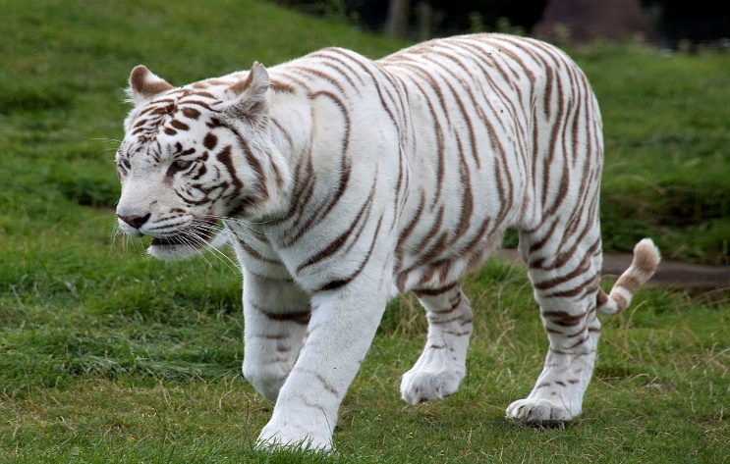

2009 Tony Hisgett, Wkimedia Commons
http://commons.wikimedia.org/wiki/File:White_Tiger_6_(3865790598).jpg
- Explain what a mutation is.
A random change in the DNA of an organism
- Explain how this mutation caused this tiger to have a white coat instead of an orange coat.
A mutation to the gene encoding for coat color caused the color to be white instead of orange.
- Which of these would most likely cause this mutation?
- the placement of ribosomes on the endoplasmic reticulum
- the insertion of a nucleotide into DNA
- the movement of transfer RNA out of the nucleus
- the release of messenger RNA from DNA
- The DNA sequence for the orange tiger and the mutated DNA sequence of the white tiger are shown below. What would the mRNA codons be for the mutated tiger?
