Design Your Own Prosthesis Worksheet
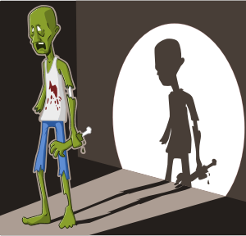
Scenario: It’s finally happened. The zombie apocalypse is here. You are among a group of survivors who have managed to remain uninfected. However, during a food search, you and your group found yourselves in an intense fight through a horde of zombies. One person in your group was bitten on the ankle. To keep the infection from spreading and the person from becoming one of the living dead, your group made the difficult decision to quickly amputate the leg below the knee. Thankfully, the person has made a full recovery and now needs some sort of prosthesis to replace the lost limb so everyone can be mobile in order to stay away from the hungry zombies!
- Begin by assessing the available materials. You will have the chance to scavenge for other supplies before you start building. Brainstorm ideas for a functional lower-leg prosthetic design. Below and on the back of this sheet, make notes of all possible design ideas.

- Choose one design that your group will attempt to construct. Sketch it on the back of this paper.
At this stage, have the teacher look at your design and offer suggestions.

- What additional materials do you need to build your design? Make a shopping list. Then look at the supply table. Your group has 4 vouchers to use to barter for additional supplies. You may decide to use all of them or only some of them. The “currency” you will use in the bartering process is your knowledge. You must correctly answer a question for each voucher you want to use.
One voucher = one chance to answer a question = one item from the supply table.

On Day 3, one group member must be able to walk unassisted for 20 feet to demonstrate how well your prosthesis functions!
- Did your prosthesis work? What are the pros and cons of your design? What modifications would you make to the replacement limb design?

- Engineers follow the steps of the engineering design process to design products and systems.
List the steps in the process.
1.

2.

3.

4.

5.

6.

7.

- If this was not a zombie attack and instead the real world, what do the vouchers represent?

