Hydrogel Lab Sheet
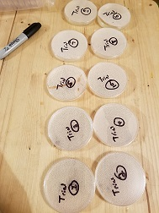
Procedure:
Day 1 – Initial Testing
- Label petri dishes (or small plastic condiment cups) with group name or mixture.
- Mass the citric acid and polymer(s) individually using a weighing boat (or small plastic condiment cup) and gram scale. Place each into the beaker (or cup).
- Measure 50 mL of boiling water and add immediately to the beaker. Stir until all is dissolved. If the substances aren’t fully dissolved, heat the solution slightly while stirring.
- Pour solution into petri dishes (or small plastic condiment cups) that have already been labeled.
- Place on counter to cool and set overnight. You do not need to refrigerate.

Day 2 – Initial Testing
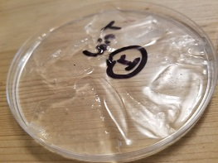
- Dry the hydrogels that completely set (should hold firm if turned on its side) using a clamp light, fan or drying oven on very low setting.

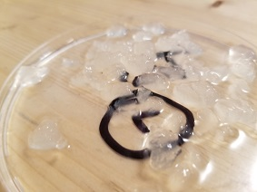
Day 3 – Initial Testing
- Cut the dry hydrogels into small pieces. This will simulate the small commercial hydrogels that are found in potting soil.
- Mass the hydrogel and container together. Record in Data table.
- Fill the petri dish (or small plastic cup) completely with water. Let sit overnight for the hydrogel to reabsorb the water.

Day 4 – Initial Testing
- Pour off any remaining water from the hydrogels and lightly dab with a paper towel.
- Mass hydrogel and container together. Record in Data table and calculate amount of water reabsorption.
Days 5-8 – Second Round Testing
- After calculating the best polymer(s) for the hydrogel based on highest water reabsorption, this second round of testing will repeat all of the above procedures using the different ratios of the chosen polymer(s).
- Repeat as needed.

Data:
 |  | Column A | Column B
 | Polymer(s) Tested | Mass Hydrogel & Container After Drying (grams) | Mass Hydrogel & Container After Water Reabsorption  (grams) | Ratio  (Column B ÷ Column A)
Round 1
Round 2
Round 3

Questions:
      - Explain how or why the hydrogels performed the way they did during the activity

      - Indicate what further questions or experimentation is needed to better support your reasoning.

