Bacteria! It’s Everywhere! Rubric

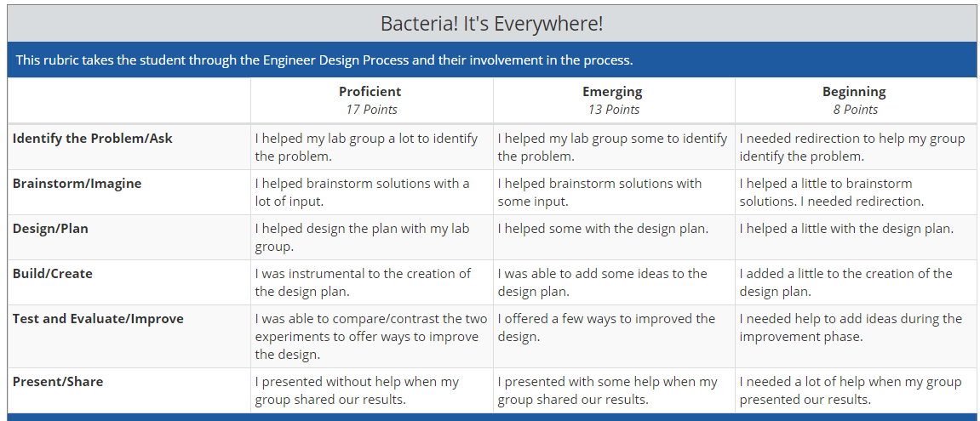

Comments:

