Parts of a Microscope Sheet Answer Key

Label the main parts of the microscope in the diagram using the helping words given in the box
power switch | focus knob | lamp
objective lens | eyepiece | stage

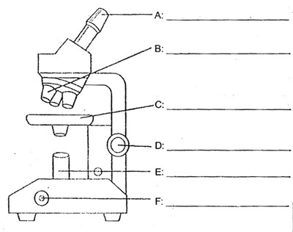

eyepiece

objective lens

stage
focus knob
power switch

lamp

