Naturally Organized Lab Notebook

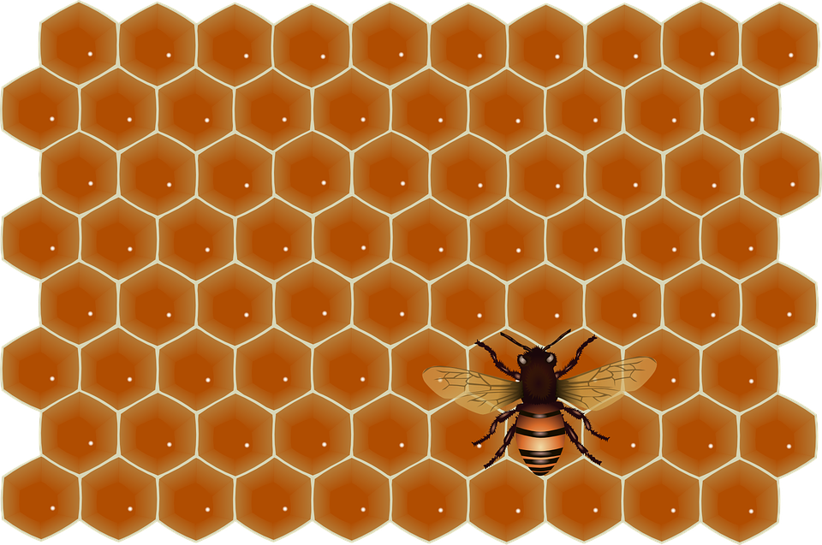

Background: In the book Wild Ideas you learned that nature has taught humans a lot about problem solving. When people use nature to design solutions to problems it is called biomimicry. Ants and bees are two of nature’s most organized insects. Many species of ants and bees live in colonies. Within these colonies there is structure – everything has a purpose and a place. Engineers observe these structures and apply them to their designs.
Design Challenge: You and your team will design a table top organizer inspired by an insect home of your choosing. Your prototype will store your team’s classroom supplies (scissors, crayons, pencils, and glue sticks). Supplies must be easily retrievable and the organizer must be sturdy enough to withstand everyday classroom wear and tear.
Criteria:
• You will work in teams of 3-4.
• You will share your design ideas with your team at a team meeting where you will come to a design consensus.
• Your team will share responsibility in creating the prototype and keep notes on the design process.
• Your team’s prototype will be peer reviewed prior to classroom testing.
• Your team’s prototype will be tested for durability and functionality in the classroom for a period of 5 school days.
• Your team will communicate your results with another team.

Your Design:
• Must be inspired by an insect’s home
• Must allow easy access of materials
• Cannot obstruct yours or another team’s view of the whiteboard
• Cannot be more than 80 cm around

Suggested Materials:
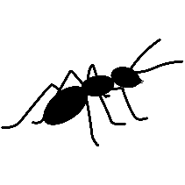

• cardstock
• cardboard
• foam sheets
• felt sheets
• beading/craft wire
• tape
• glue
• scissors
• stapler (w/teacher assistance)
• hot glue (w/teacher assistance)

Naturally Organized

Team members: _____________________ _____________________
_____________________ ____________________
Research
Organizer # ________  1. Does the organizer allow easy access to supplies?  Yes No  2. Does the organizer obstruct the view of yours or another team’s?  Yes No  3. What is the organizer made of?  _______________________  _______________________  4. What does the organizer use to separate materials (e.g. drawers, dividers)?  _______________________  _______________________  5. Additional Notes: | Organizer # ________  1. Does the organizer allow easy access to supplies?  Yes No  2. Does the organizer obstruct the view of yours or another team’s?  Yes No  3. What is the organizer made of?  _______________________  _______________________  4. What does the organizer use to separate materials (e.g. drawers, dividers)?  _______________________  _______________________  5. Additional Notes: | Organizer # ________  1. Does the organizer allow easy access to supplies?  Yes No  2. Does the organizer obstruct the view of yours or another team’s?  Yes No  3. What is the organizer made of?  _______________________  _______________________  4. What does the organizer use to separate materials (e.g. drawers, dividers)?  _______________________  _______________________  5. Additional Notes:

Plan
1. What is the problem? Restate the design challenge in your own words.
____________________________________________________________________________________________________________________________________________________________________________________________________________________________________
2. What materials will you use to create your prototype? Why?
________________________________________________________________________________________________________________________________________________________________________________________________________________________________________________________________________________________________________________
3. What insect’s home will inspire your design? Why?
____________________________________________________________________________________________________________________________________________________________________________________________________________________________________
4. What 2-dimensional shape(s) will you using in your design?

Brainstorm Solutions
Draw and label your ideas.
Solution #2
Solution #1

Team Design Consensus:

Develop and Build your Prototype

Materials Engineer – I will pay attention to what materials my team selects and how they are used. I will make sure materials are shared with all members of the team.

LAB NOTES

Manufacturing Engineer – I will carefully observe and record the steps my team performs to create our prototype.

LAB NOTES

Structural Engineer – I will make sure our prototype is 80cm or less around and can support the size and weight of our supplies. I will frequently use my tape measurer to measure the prototype as it is being built.

LAB NOTES

Biological Engineer – I will make sure our design is inspired by nature. I will frequently ask questions throughout the design process such as, “What would nature do?” or “What would nature NOT do?”

LAB NOTES

Naturally Organized
Prototype Peer Review

Name of Peer Reviewer: ________________________________________________

Write down at least 1 thing you liked about the prototype.

Write down at least 1 thing you think could be improved.

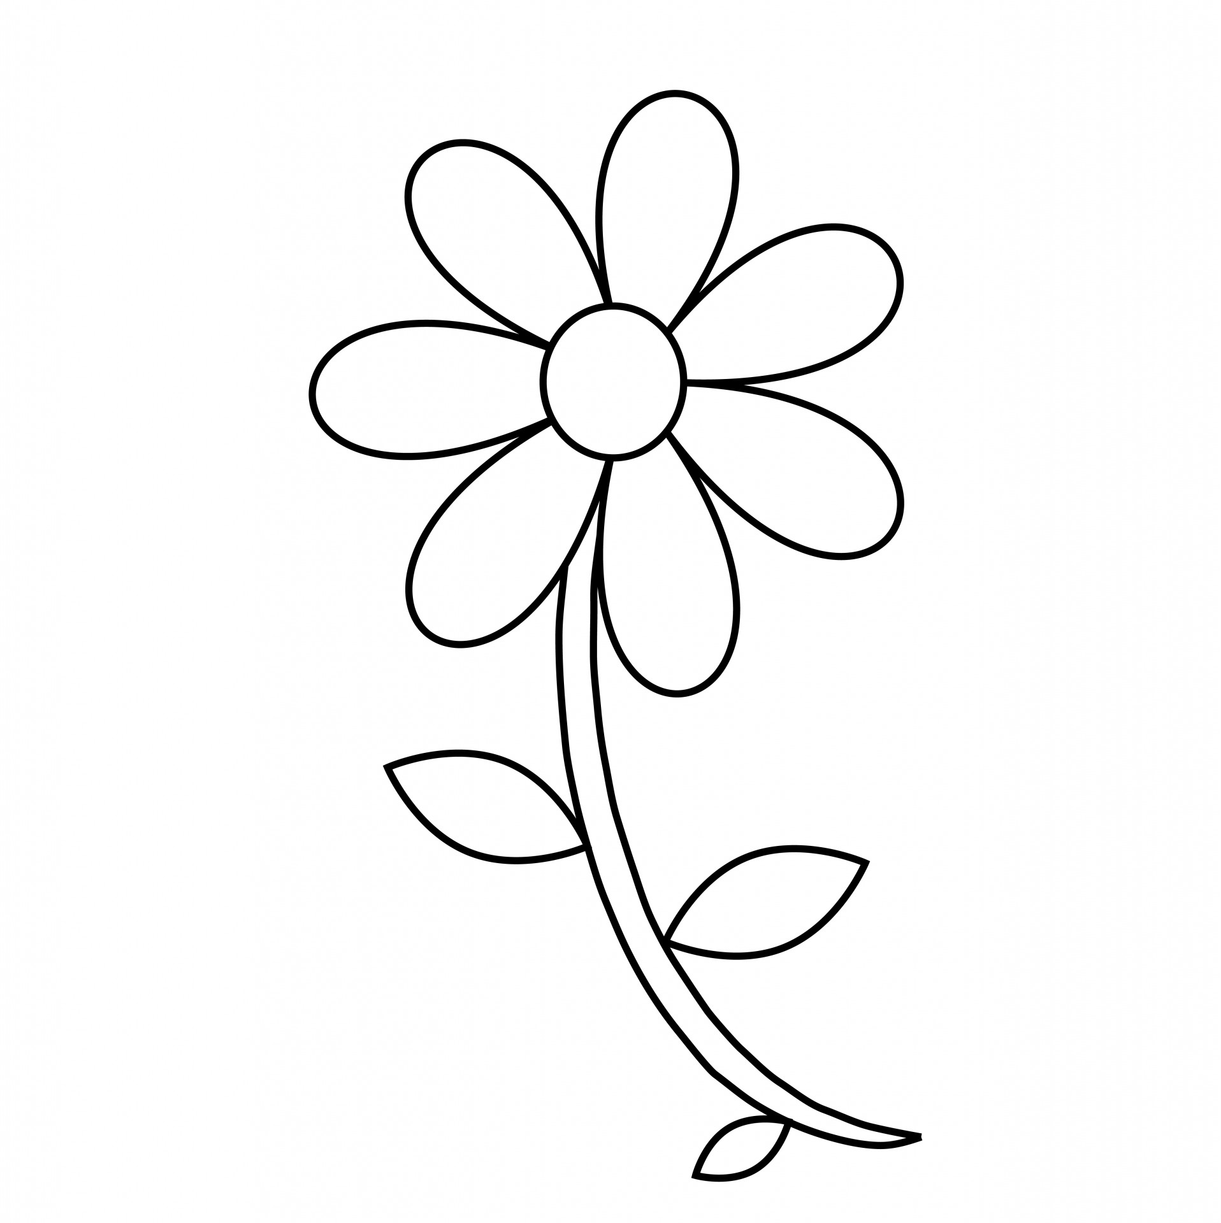

Naturally Organized
Test your Solution
 |  | Yes | No
Does your prototype allow everyone at your table to easily access supplies?

Is your prototype 80 cm or less around?

Does your prototype obstruct the view of yours or
another team’s?

Is your prototype still intact and self-standing after
5 days of classroom use?

Evaluate your Solution

- Do you think you came up with the best design? Why or why not?

__________________________________________________________________________________________________________________________________________________________________________________________________________________________________________
- What would you differently to make your solution better?

__________________________________________________________________________________________________________________________________________________________________________________________________________________________________________

Naturally Organized
Communicate Your Results

Item Name
Product Dimensions
Record the length of each side of your prototype

*If your design’s base is a circle, record the circumference in cm
Color(s)
Material Type
Record the materials used to create your prototype
Size
Add up the length of each side of your prototype and record the total in centimeters (cm)

*If your design’s base is a circle, record the circumference in cm

Naturally Organized
Communicate Your Results

Directions: You and a teammate will meet with another team that has completed the same design challenge as you. You will use this conversation guide to compare and contrast your designs.

Topic 1: Introduction
Our team designed a _____________________________. It was inspired by
(what you made for the design challenge)

__________________________________. We chose this insect’s home because
(name of insect and type of home)

________________________________________________.
(list reasons)

Topic 2: Methods
We made our tabletop organizer out of ___________________________________.
(list materials used)

We chose these materials because __________________________________________.
(list reasons)

It was challenging to ________________________________________________________.
(list what was hard to do)

Topic 3: Results
After 5 days of testing, we discovered _______________________________________.
(list things that happened to your prototype)

Topic 4: Discussion
We think our design (worked/did not work) well because ____________________.
(list reasons)

If we could change anything to make it better, we would ___________________.
(list reasons)

Topic 5: Acknowledgments

I like how….
That was a great way to…
Nice work showing…
You showed great effort when...

Design Brief Rubric | I did not. | I did with A LOT of help from a teammate or teacher. | I did with SOME help from a teammate or teacher. | I did this all on my own.
I identified the problem to be solved.
I brainstormed more than one solution to the problem.
I created and labeled a sketch of the final prototype.
I included notes related to my engineering job in the design process.
I measured the table organizer correctly with appropriate measurement tools.
I completed the Prototype Peer Review for another team and wrote objective feedback.
I tested the organizer to make sure it was durable, less than 80cm around, did not obstruct anyone’s view, and allowed for easy access of supplies.
I evaluated my solution objectively.
I contributed to a conversation with another team on the results of my team’s design.
Engineering Design Process Rubric

