Decibels Pre-Quiz Answer Key

- What causes a sound to occur?
An object that vibrates.
- What are three materials that absorb sound?
Foam, cotton, blanket, towel, and cloth (answers may vary)
- What are three materials that reflect sound and cause an echo?
Plastic, glass, and stone (answers may vary)
- What mediums can sound travel through?
Solid, liquid, and gas.
- If you are soundproofing a room, this means you are doing what?
You are using a material that will prevent the passage of sound.
6. 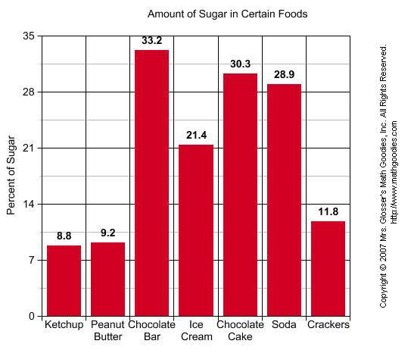
- What is the information that this graph is showing you? % of sugar in different types of food

- What is the difference in percentage in sugar between ice cream and crackers? 9.6

- What has the highest percentage of sugar? Chocolate Bar

- What is being measured on the y axis? % of Sugar

- What goes on the x axis? Different types of food

