Physical Testing Lab—Strength

Materials:

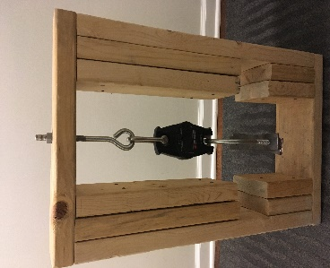
- block crushing machine (right) including:
  - 1 small crane scale, available at Amazon
- gallon heavy-duty Ziplock bags for drop test: a safe height clear of people (such as a stairwell or off bleachers) after having been tested in the block crushing machine
- Extra Individual Assignments sheet: only one block can be tested at a time (optional).
- A premade sample cement block to use as a reference/control (optional).
Procedure:
- Take pictures of your brick from a couple of angles. Consider including yourself in the picture.
- Listen to those running the crusher and record your data for your cement as it goes through the crusher apparatus. Every turn of the wrench is equal to 5 millimeters of extension. Record the amount of force applied for every turn.
- Take pictures of your brick afterwards several angles. Be sure that the viewer can see how the brick broke. This is important to material science engineers; the data helps them redesign/create stronger composite materials.
- Save the data to your personal files for the final presentation/assessment.
Data Table:
Extension (Turns) | Force (N) |  | Extension (Turns) | Force (N)

After data collection is complete, create a graph using Google Sheets so you can share it with the rest of the class. The extension will be on the x-axis and the force will be on the y-axis. These graphs will be able to be used to determine the overall effectiveness of the material that makes up your concrete composite block.

Analysis:
- How did your composite perform? Be as descriptive as possible. What was its max load? What was its max extension?

- Did the results of the test surprise you in any way? Explain.

