**Block Crusher Design Instructions**

**Materials**:

2 x 6 x 8 inch pieces of lumber (2 pieces)

8 inch eyebolt, with washer and nut that fit

6 inch U-bolt with washers and nuts

16 inch long piece (or 2-8 inch pieces) of 1/4in steel

300 lb. crane scale

1 or 2 inch wood screws (box)

**Tools:**

Electric drill

Saws (for wood and metal)

Tape measure

Drill bits

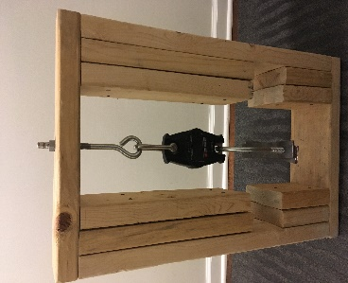

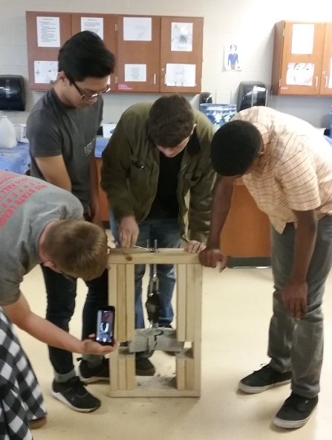

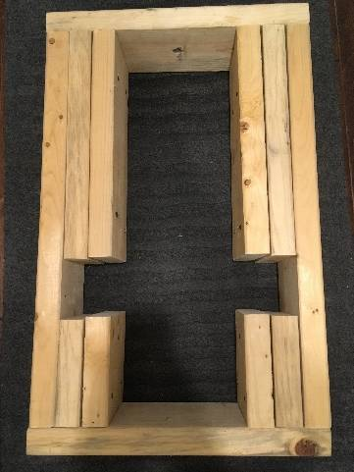**Assembly Instructions:**

1. Cut the lumber:
   1. 4 pieces, 14.5 inches long
   2. 4 pieces, 6 inches long
   3. 2 pieces, 24.5 inches long
   4. 2 pieces, 17 inches long
2. Assemble the frame:
   1. Make a box that is 17 inches wide and 27.5 inches tall. (**Figure 1**)

**Figure 1**

* + 1. Use the two 17 inch pieces at the top and bottom

**Figure 1:** The 17 inch pieces lay across the top and bottom. The 24.5 inch pieces are the sides of the frame. The 14.5 inch and 6 inch pieces are the internal supports.

* + 1. Screw the 24.5 inch pieces into the sides of the box, so that they sit inside the 17 inch pieces.

1. Add the supports
   1. On the inside of the box, attach the other pieces of lumber. Start at the top of the box, and screw the top corners the 14.5 inch pieces; two of them on each side. (Figure 2a)
   2. At the bottom of the box, attach the 6 inch pieces. (Figure 2b)

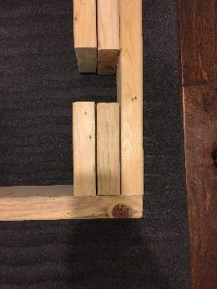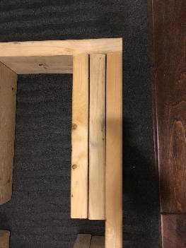

**Figure 2a**

**Figure 2b**

**Figure 2a and 2b**: Details of the internal support. Place two 14.5 inch pieces at the top running along each (inner) side and two 6 inch pieces at the bottom along each (inner) side. There should be a gap in the middle.

1. Make the test rig.
   1. Find the middle point of the top of the frame. Drill a hole just larger than your eye bolt; it will be attached up there (Figure 3a and 3b).
   2. Cut the steel pieces into 2- 8inch pieces.
   3. Measure the width of the U-bolt and drill holes into both pieces of the metal so that the U-bolt can slide into it. (Figure 4a)
   4. Attach the U bolt to the bottom of the crane scale and the eye bolt to the top; your machine is complete. (Figure 4b) 😊

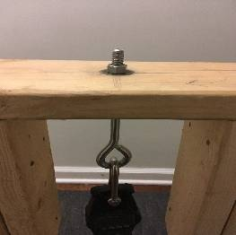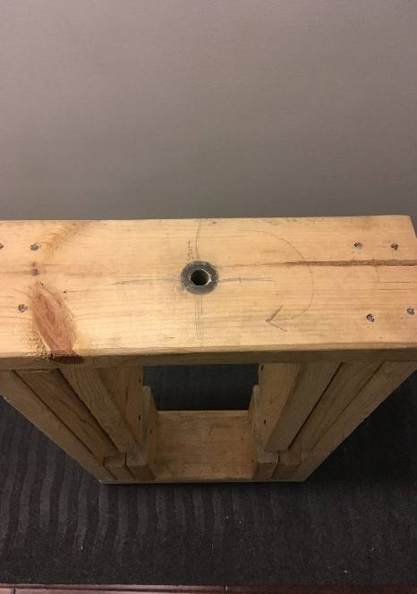

**Figure 3b**

**Figure 3a**

**Figure 3a**: Drill a hole in the middle of the top piece of lumber for the eyebolt.

**Figure 3b**: Place the eyebolt into the hole; fasten with a washer and nut.

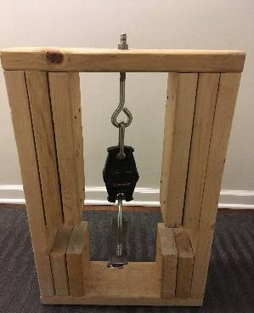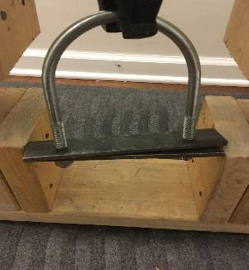

**Figure 4a:** Attach the two pieces of steel to the U-bolt; take care to drill the holes carefully. The nuts and washers of the U-bolt hold the steel in place.

**Figure 4b:** Congratulations! The finished product!

**Figure 4b**

**Figure 4a**