Controlling the Curiosity Rover
ANSWER KEY

1) Create a list of moves that the rover (currently facing right) will have to execute to get from the landing site (X) to the alluvial fan area (Y)(must face to the left).
Command choices: forward (F), backwards (B), left (L), right (R), stop (S)

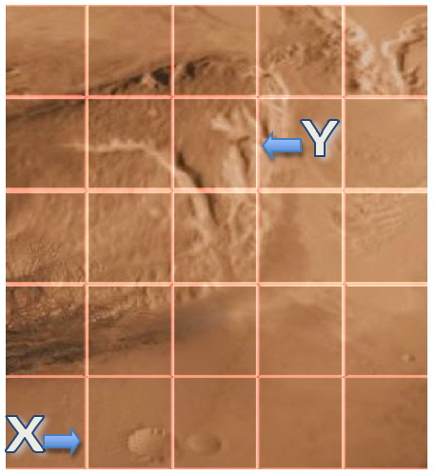

Moves List:
There are many different solutions to solve this problem. As long as the craters are avoided by the student’s rover and the requirements are met, the student’s solution is valid. A possible set of steps is as follows:
- Forward 1 square
- Turn left
- Forward 1 square
- Turn right
- Forward 3 squares
- Turn left
- Forward 2.5 squares
- Turn left
- Forward .75 squares
10) Stop

2) Use the mobile device and Rover App to test moves list on app rover.

3) Redesign moves list as needed to improve app rover path.

Revised Moves List:

Varies by algorithm

4) Test moves list on EV3 rover to see if simulation fits reality.

5) Redesign moves list as needed to improve EV3 rover path.

Revised Moves List:

Varies by algorithm

6) Explain how you applied the design process in this experience by detailing each step in the process.

The answers below are sample responses.

Analysis

We had to analyze the problem and determine a path from point x to point y. There was terrain with craters and other rough ground that had to be avoided. In addition, we felt that efficiency was important so we wanted to create a short path.

Design

We constructed steps to move the robot. We had to consider the problems we identified in the analysis step.

Implementation

We entered the steps we designed into the Android device using instructions we received from our teacher.

Testing

Testing comprised of running the program to determine if we solved the problem correctly. When the program ran, we encountered some difficulties. The rover did not drive exactly as we thought it would do to some slippage on the floor.

Evolution

We went back to the design cycle and through observations made corrections to our initial design, which we implemented and tested. Finally, the rover behaved per the guidelines outlined in the initial problem.

