Example of Pseudo-code from the Accelerometer App written in MIT’s App Inventor Programming Language:
The image below shows a piece of code written in MIT’s App Inventor language. The purpose of the code is to measure acceleration readings from the device and store the values in a database with as a key and value ordered pair (time and acceleration). The pseudo code that could be written as a plan for this is included below the image.
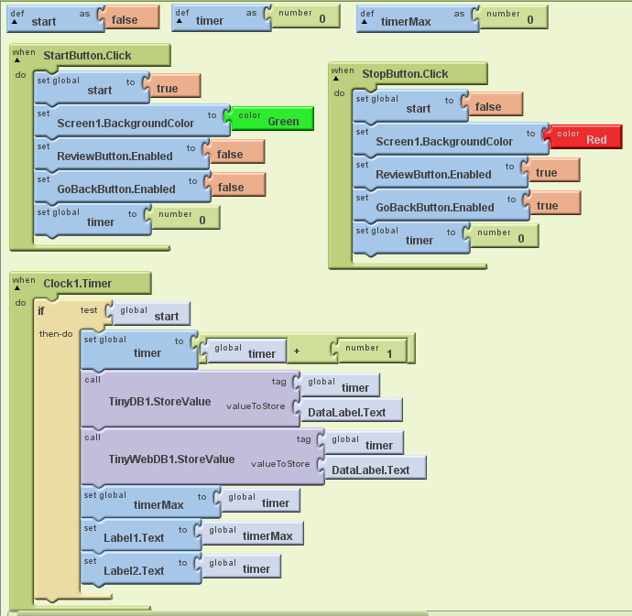
make new variables with given initial values:
start = false
timer = 0
timerMax = 0
When the StartButton is clicked:
set start to true
set Screen1 background to green
disable ReviewButton
disable GoBackButon
set timer = 0
When the StopButton is clicked:
set start to false
set Screen1 background to red
enable ReviewButton
enable GoBackButon
set timer = 0
When Clock1 advances time:
if start is true, do the following:
increment time by +1
make entry in TinyDB1 with an ordered pair (timer, DataLabel text)
make entry in TinyWebDB1 with an ordered pair (timer, DataLabel text)
set timerMax = time
set Label1 text = timerMax
set Label2 text = timer

