Loops and Switches Worksheet Answer Key
PART 1 (Day 1)
start/stop at this corner
Suppose we want to make a robot move once around in a square pattern as shown on the right. Assume 2 feet on each side.
To do this, the robot needs to go forward, then turn right, then go forward, then turn right, then go forward, then turn right, then go forward and turn right to get back to its original position.
- Write, in English, the steps of how you would have a robot do this.
- Move forward 24 inches
- Turn right
- Move forward 24 inches
- Turn right
- Move forward 24 inches
- Turn right
- Move forward 24 inches
- Turn right
- Now, use LEGO blocks to implement this (as shown on slide 6, but do this without looking at the slide).

- Now, do this using the loop idea introduced in class (as shown on slide 10, but do this without looking at the slide).
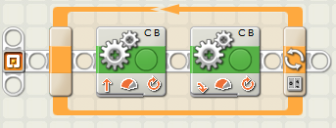
Details of loop block shown below
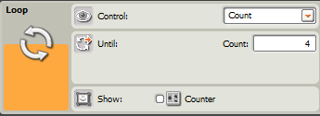

PART 2: Mini-Activity 1 (Day 1)
Using the loop command, program the robot to:
- Go forward until it hits a wall, then back up one rotation turn left.
- Repeat the above instructions until the robot detects a sound.
- Then stop.
- Write the logic you will use to program this task.
- Move forward.
- Wait until the touch sensor is pressed.
- Back up one rotation.
- Turn left.
- If the sound sensor does not perceive a sound, repeat.
- Else, if the sound sensor hears a sound, stop.

- Sketch out the program below, in the form of NXT software blocks, and discuss with your group partner to make sure it will work. Then implement it on the robot.

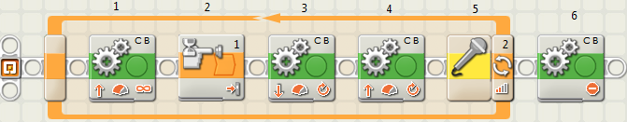

PART 3: Mini-Activity 2 (Day 2)
Program the robot to end up exactly 24 inches from a wall, no matter where you start.
- So the robot can be in one of two states; either 1) the robot is closer than 24 inches to the wall or 2) the robot is farther than 24 inches from the wall.
- Program for this task using a switch statement.

- Write out the logic you will use to program this task (as discussed on slides 14-18).
- If the ultrasonic sensor perceives an object less than 24 inches away
  - Move backwards
  - Wait until the ultrasonic sensor perceives an object at least 24 inches away, then stop
- Else if the ultrasonic sensor perceives an object more than 24 inches away
  - Move forward
  - Wait until the ultrasonic sensor perceives an object at most 24 inches away, then stop

- Sketch the NXT program below, and discuss it with your group partner to make sure it will work. Then implement it on the robot.
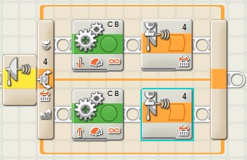

PART 4: Mini-Activity 3 (Day 2)
Program the robot so that it moves forward until it hears a sound. If the touch sensor is pressed when it hears a sound, the robot should turn left. If the touch sensor is not pressed when it hears a sound, the robot should turn right. Use the switch statement.
- Write the logic you will use to program this task (as discussed on slide 20).
- Move forward
- Wait until a sound is heard
- If the touch sensor is pressed, turn left 0.5 rotations
- Else if the touch sensor is not pressed, turn right .5 rotations

- Sketch the NXT program below, and discuss it with your group partner to make sure it will work. Then implement it on the robot.
