Tower to the Moon Main Activity (GrK-2) Answer Key
Your design challenge: Following the steps of the engineering design process, build the tallest straw tower possible using no more than 50 plastic drinking straws and 1 meter of tape?
- Imagine: Draw and label how you would build the tallest straw tower with 50 disposable drinking straws and one meter of tape. Label the materials used.
50
For this design, how many straws do you need? ______________
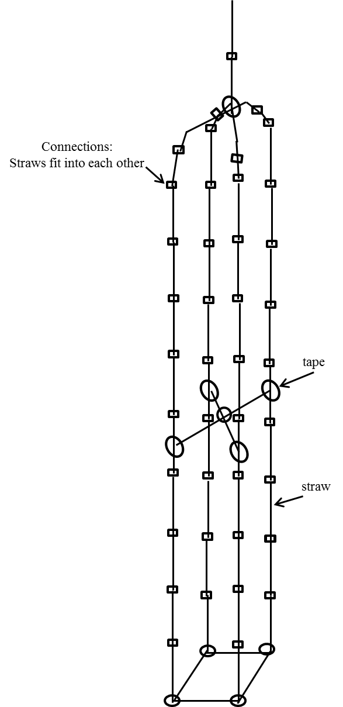
Example answers

- Plan: Are you selecting your design solution or your partner’s design solution?
Circle one: mine partner’s

- Improve: After seeing what your classmates have created, draw a new and improved design. Label the materials used.
50
For this design, how many straws do you need? ________
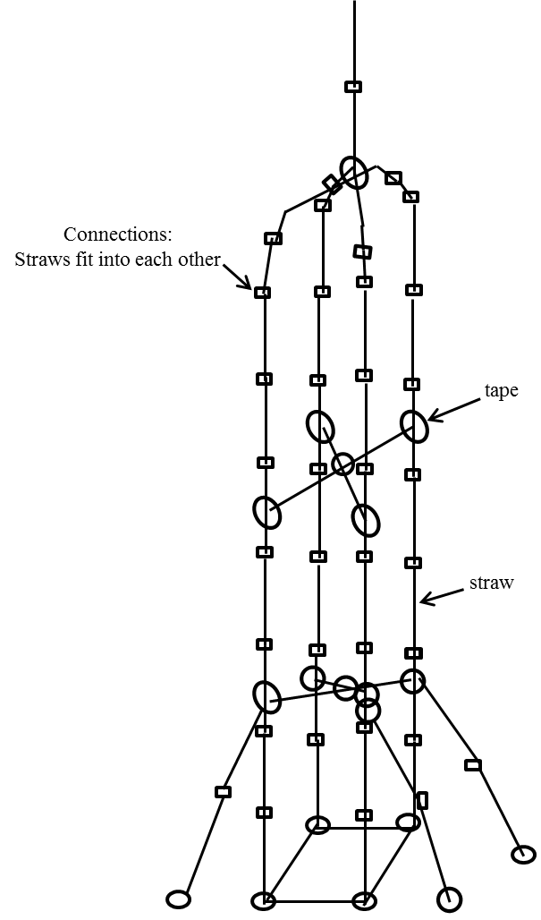
Example answers

