Construction and Competition Rules
Description
Competitors build a car using only dry pasta and glue.
The winning entry is the car that travels the furthest distance past the end of the ramp.
Event preparation: Build entry prior to the competition
Grade level: 4-7
Team size: 1-2 students
Maximum number of entries: Unlimited
Materials
M.1 Any kind or shape of dry pasta.
M.2 Any type of glue or adhesive.
M.3 A ramp and a course on a smooth floor.
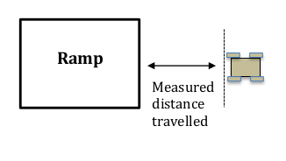
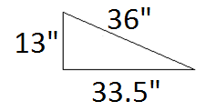
Measure
distance
traveled from ramp end to stopped car
Starting line

Stopped car
Ramp side view
Course top view

Construction Rules
C.1 The only materials that may be used to build the car are described in M.1 and M.2.
C.2 After a completed car is turned in prior to the event, no further work may be performed.
Competition Rules
R.1 Practice runs are permitted based on available time. Only one judged run is permitted. The judged run must be clearly requested by the competitor prior to starting.
R.2 Prior to release down the ramp, the car’s rear wheels must be touching the designated start line or upper edge of the ramp. The car may not be pushed down the ramp. The judge will announce a countdown to car release.
R.3 Cars may not be interfered with until they come to a complete stop.
R.4 Distance is measured perpendicularly from the end of the ramp to the part of the stopped pasta car closest to the ramp.
Scoring and Awards
S.1 The winning vehicle is the one that travels the furthest distance past the ramp end.
S.2 In the case of any tie, the heaviest car wins.

