Engineering Design Process Worksheet
3. Imagine: Brainstorm ideas for solutions.

2. Research: How did you research this topic?
_____________________________
- Ask: What is the problem?
________________________________________________________________________________________________________________________________

4. Plan: Draw a diagram. What materials will I need?
Design:

6. Test: Evaluate my pedometer by comparing it to another step counter app. Record results here:
My pedometer: ________ steps
App pedometer: ________ steps
Are there any differences? Why?
_________________________________________________
_________________________________________________
_________________________________________________
_________________________________________________
Materials:
- ____________________
- ____________________
- ____________________
- ____________________
- ____________________
5. Create: Build my prototype.

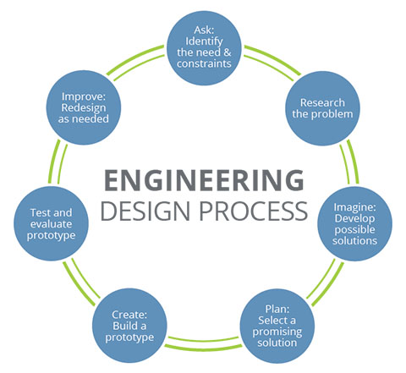
7. Improve: How can I improve my prototype?
________________________________________________________________________________

