# Experimental Setup Build Photos

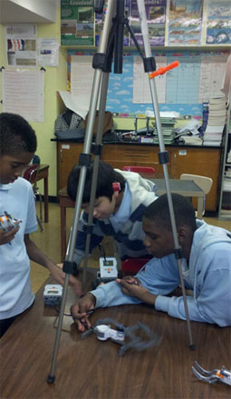

The experimental setup for performing the Foucault pendulum demonstration.

To record an oscillating pendulum, use LEGO pieces and servo motor to make a turntable that holds the video camera (a smartphone, in this case) and is connected to a LEGO intelligent brick.

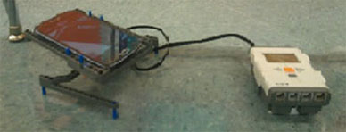

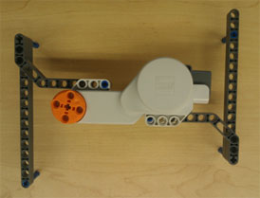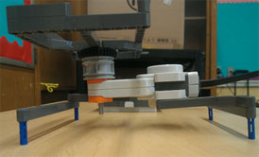**Various views of the turntable mechanism**

The base attached to a LEGO servo motor.

The entire turntable.

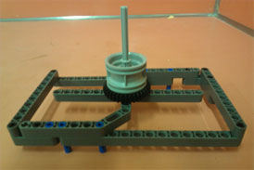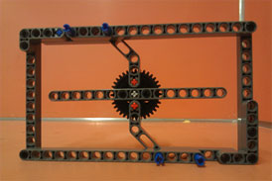

The top view of the camera support.

The underside view of the camera support.