Rube Goldberg Rubric

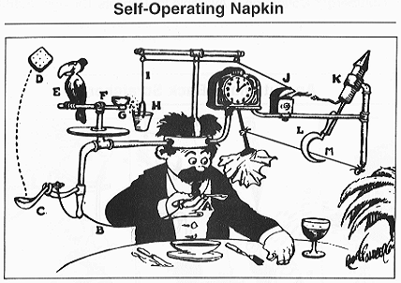

 | Points | Total
The device uses all 6 simple  machines. | 10 pts each
Each team member made  two steps. | 20 pts
All the steps in the device  works together. | 20 pts

