**Principles and Elements of Design Handout**

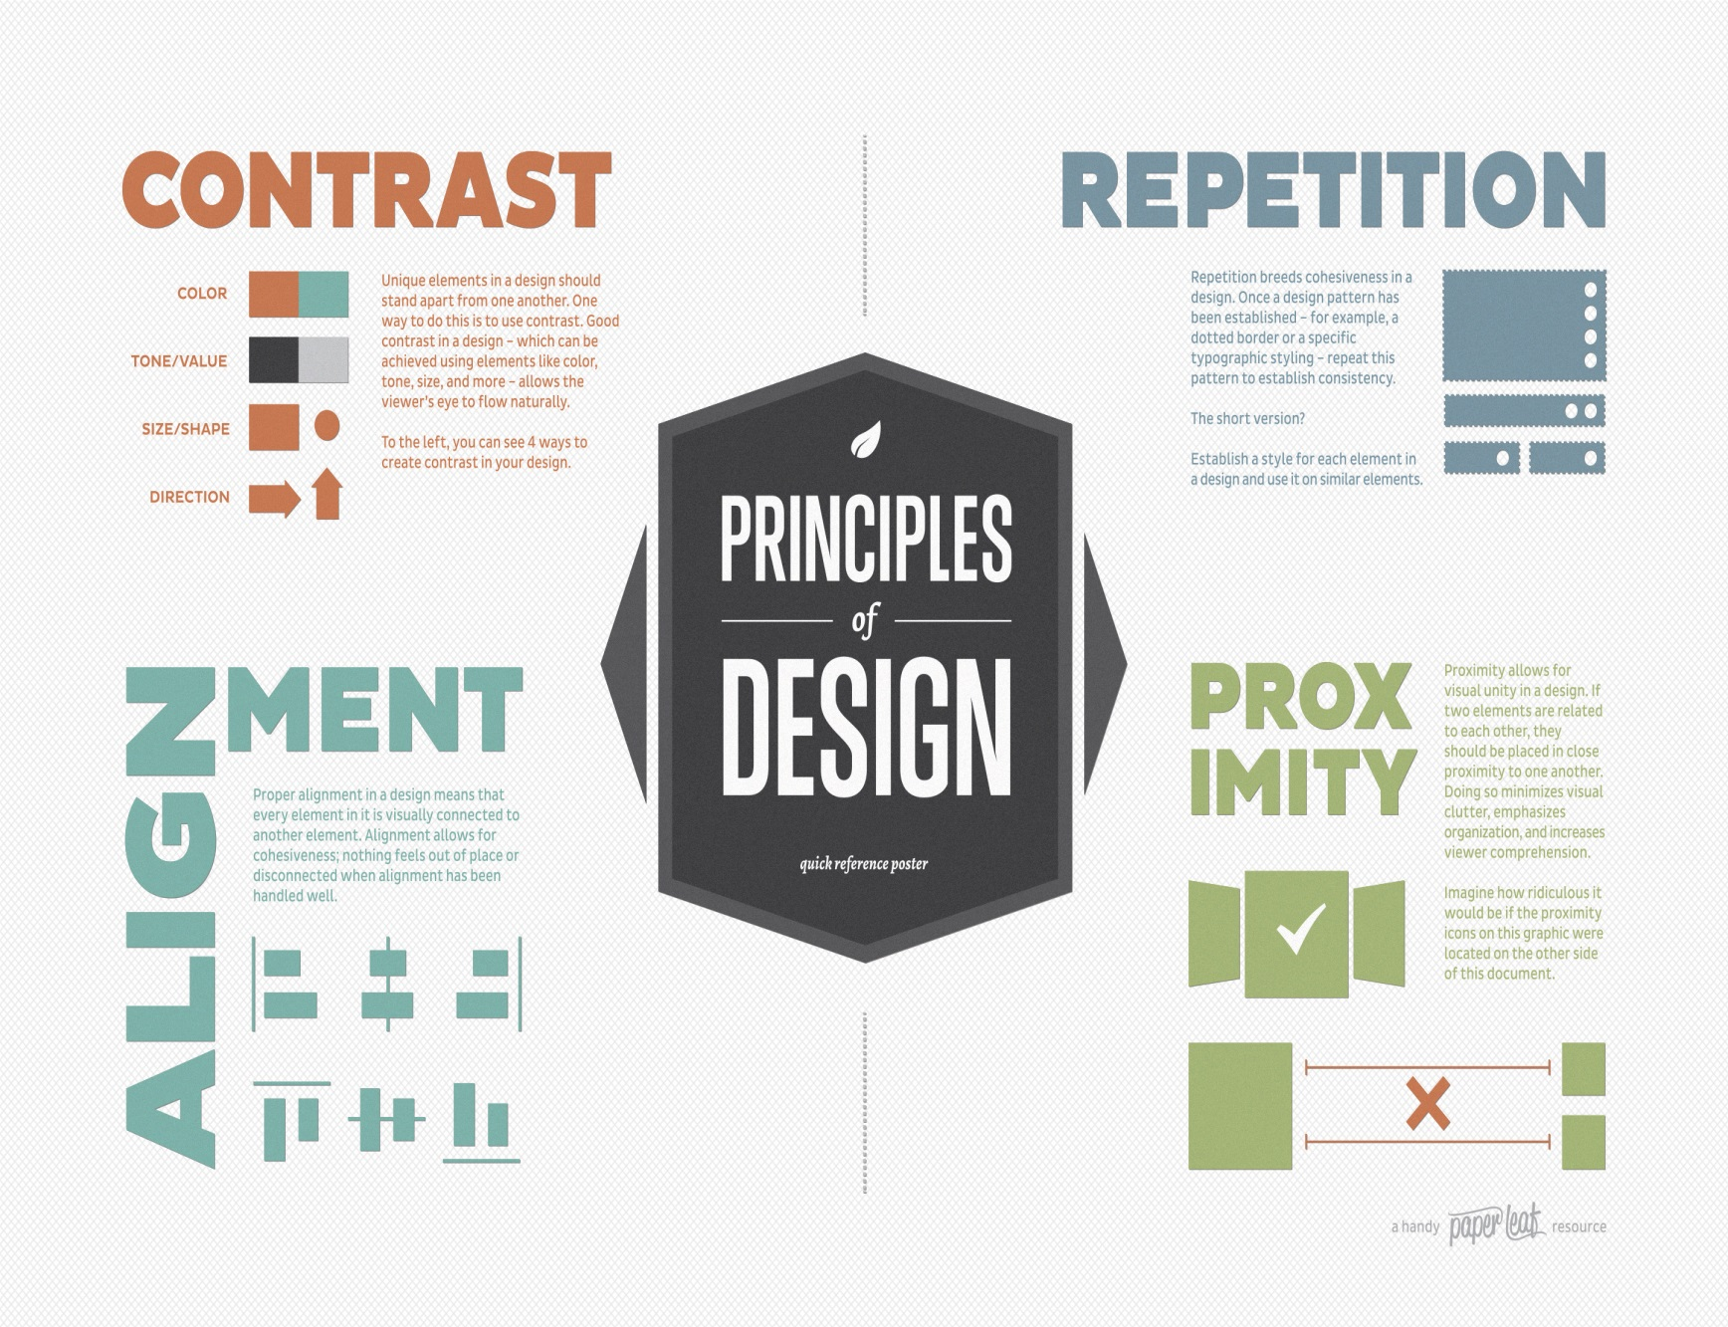

Image 1 source (free) Paper Leaf Design http://paper-leaf.com/blog/2012/10/principles-of-design-quick-reference-poster/

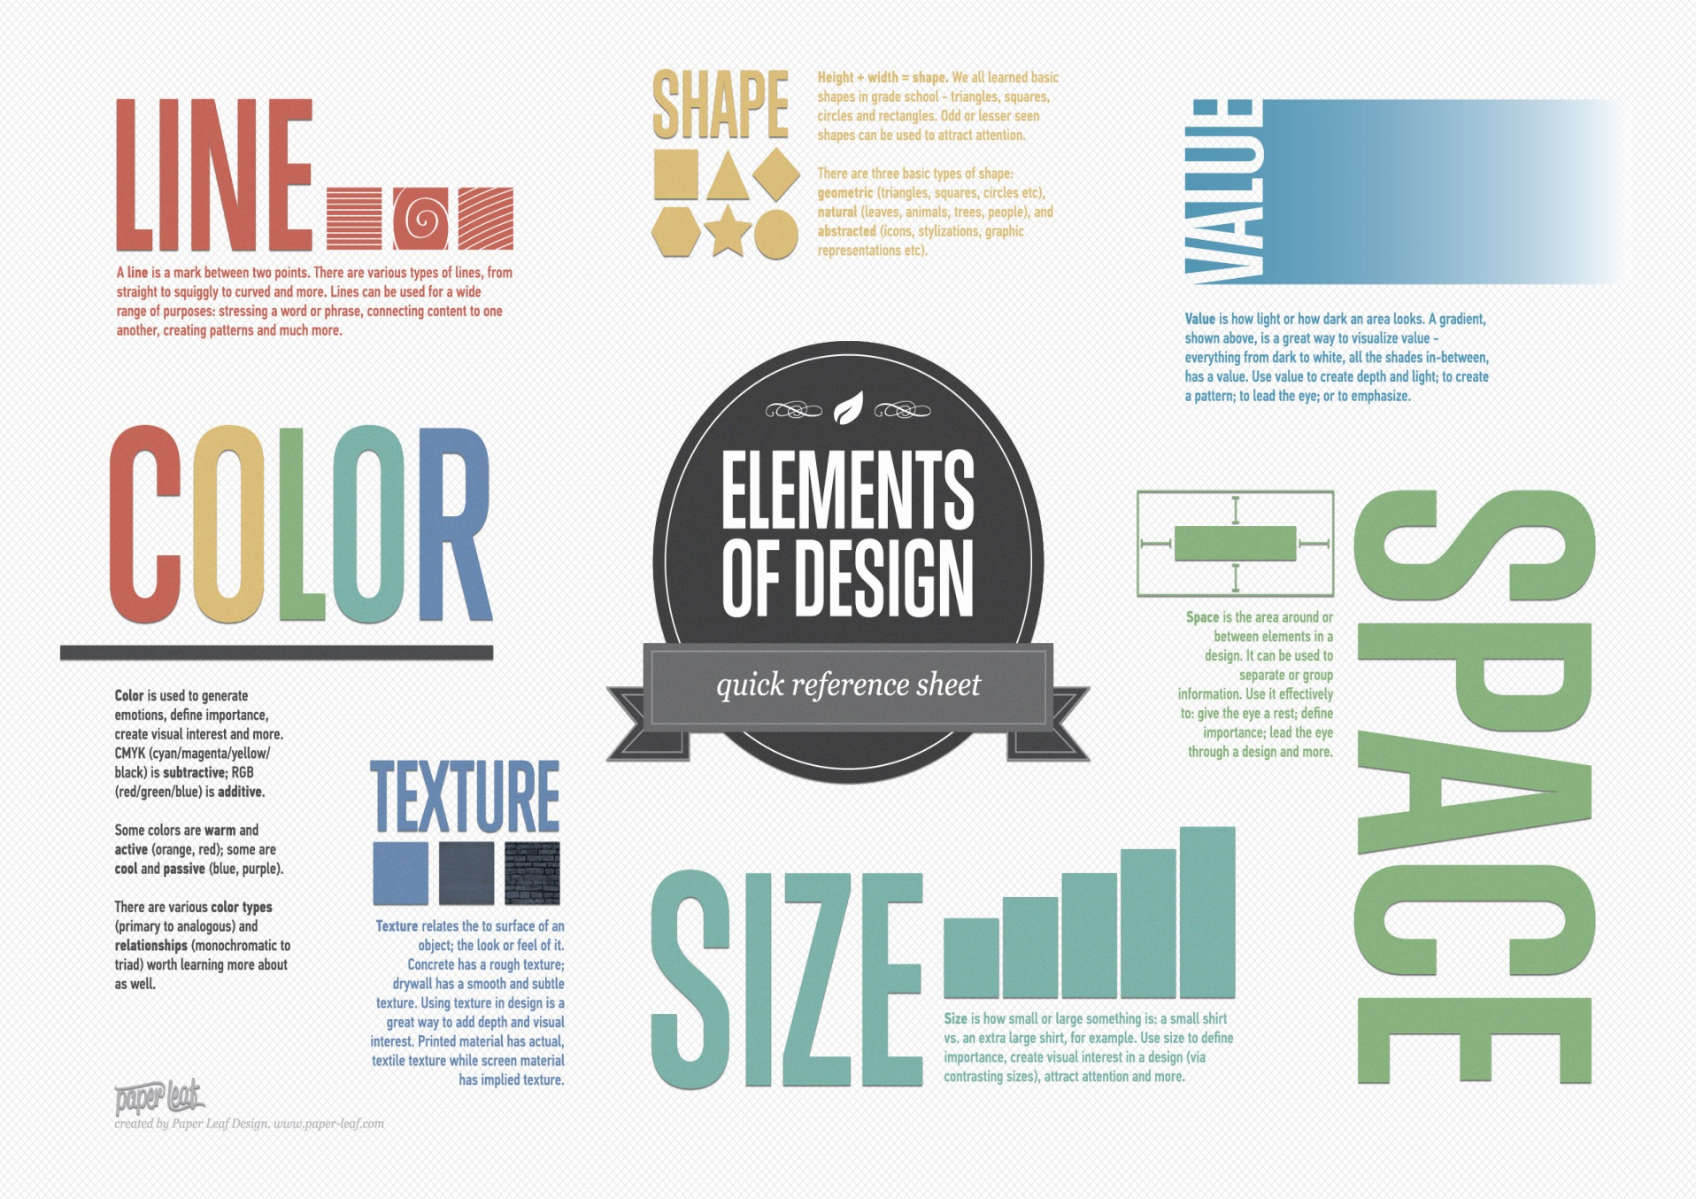

Image 2 source (free): Paper Leaf Design: http://paper-leaf.com/wp-content/uploads/2011/02/EoD_White_2560.jpg