Making Connections Worksheet Answer Key
The Arduino Sensors
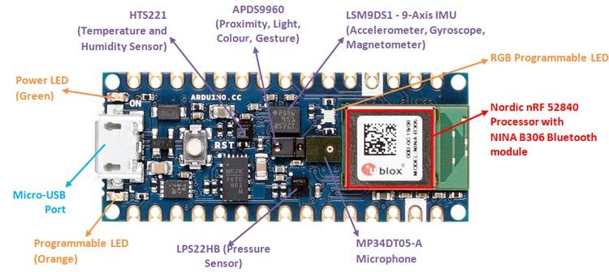

Based on the information you have learned so far, please label the sensors that act as the eyes (sight), ears (hearing), and fingers (touch).

The student should circle the microphone as the ears, temperature & humidity sensor as fingers, and the proximity, light, color, and gesture sensor as eyes.

Please answer the following question in complete sentences.

- How are sensors similar to our five senses?

The sensors on the Arduino are similar to our senses because they detect specific information and then send that information to our brains.

