Tracking a Virus Worksheet Answers

Part 1: Please answer questions 1-6 in complete sentences.
1. What do the letters A-I-D-S stand for?

AIDS stands for acquired immunodeficiency syndrome.

2. What do the letters H-I-V stand for?

HIV stands for human immunodeficiency virus.

3. What is the difference between AIDS and HIV?

HIV is a virus that can cause an infection, where AIDS is a syndrome, a collection of maladies, rather than one specific disease.

4. How does a virus survive and reproduce in the human body?

A virus attaches itself to a host cell and injects its DNA or RNA into the host. The viral genetic material shuts down the host cell's normal activity, then the virus DNA or RNA hijacks the cell's protein-making machinery and instructs it to make new viruses instead. Soon the cell becomes so full of viruses that it bursts open, releasing them to attack host cells of their own.

5. Why is HIV especially deadly compared to other viruses?

HIV attacks some of the most important cells of the immune system, the helper T cells (also known as T4 cells or CD4 positive T cells). Because the immune system itself is attacked, the body is unable to rid itself of the virus.

6. How is HIV transmitted from one person to another?

HIV is transmitted through either semen or blood.

7. Circle the correct answers:
AIDS / HIV causes AIDS / HIV

Part 2: Fill in the Blanks

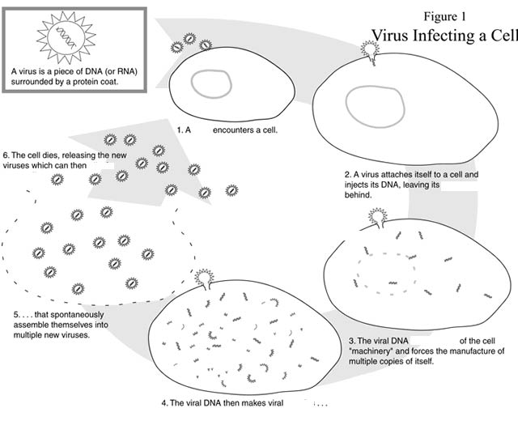
attack more cells
proteins
takes control
protein coat
virus

2.
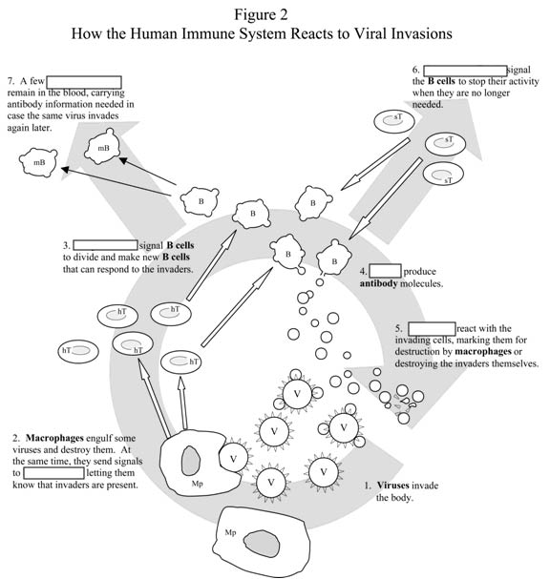
Helper T cells
^ helper T cells
Antibodies
B cells
suppressor T cells
memory B cells

