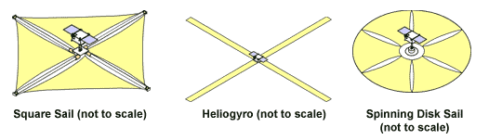

**Square Sail**

**(not to scale)**

**Heliogyro**

**(not to scale)**

**Spinning Disk Sail**

**(not to scale)**