**Agricultural Engineering: Cutting through Soil Activity – The Parts of a Plow Handout**

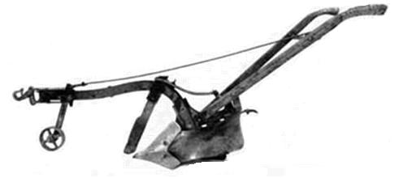

**Coulter**

**Plowshare**

**Moldboard**

**Handles**

**Beam**

**Hitch**

Source: <http://www.fhwa.dot.gov/environment/Fspubs/96232802/fig15.jpg>

**Coulter** – A sharp wedge that goes in front of the share and cuts vertically through the soil.

**Plowshare** – the wedge shaped piece that cuts the soil horizontally.

**Moldboard** – A curved piece above the plowshare that turns the soil over as it is cut by the plowshare.

**Handles** – used by the operator to control the plow.

**Beam** – the main support of the plow.

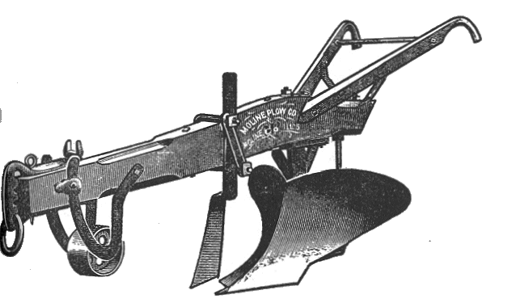**Hitch** – used to attach the plow to the horse or oxen.

**Another Example Plow**

Can you label the parts in the picture below?

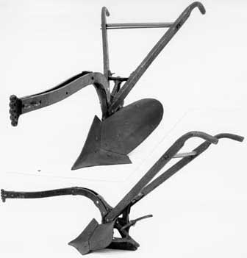

Source: <http://www.fhwa.dot.gov/environment/Fspubs/96232802/fig14.jpg>

What part is this plow missing?